CORPORATE LEVEL COMPLIANCE

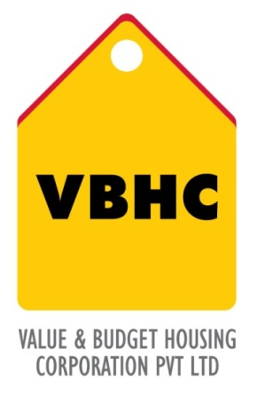
Document Control No : VBHC/FIN/P/05
Revision No : Rev 1.0
Date of Revision : 31st August 2013

 | Name/Designation | Signature | Date
Written By
Reviewed By
Approved By

HISTORY OF REVISIONS

Revision No. | Revision Date | Chapter/clause no.  & text affected | Reason for Revision

TABLE OF CONTENTS
SL No. | CONTENTS | PAGE NO.
1. | Purpose | 1
2. | Process Trigger | 1
3. | Scope and Application | 1
4. | Process Owner  5. | 1
5. | Successor and Predecessor | 1
6. | Responsibilities & Authorities | 1
7. | Definitions and Abbreviations | 2
8. | Process Flow Chart | 2
9. | Process Description | 3
10. | Efficiency measures and effectiveness measures | 3
11. | Risk associated with the process | 3
12. | Formats for maintaining records | 4
13. | Records | 4

CORPORATE LEVEL COMPLIANCES

- PURPOSE
To ensure full compliance with regulations related to taxes and other applicable at the corporate level

- PROCESS TRIGGER
The process is involved throughout the entire span of the project, from the process of acquiring land to project closure.

- SCOPE AND APPLICATION
Parent company (VBHC) and all sister concerns.
Applicable in all financial regulations – taxes, TDS , filing returns etc.
4.0 PROCESS OWNER
Finance – Head / Controller
- PREDECESSOR AND SUCCESSOR PROCESSES
Predecessor Process: Corporate Financial Planning
Successor Process: Financial Reporting for Corp and SPV’s

- RESPONSIBILITY AND AUTHORITY
Computation of taxes: Finance Department
Tax analysis: Finance Department
Composition of Taxes: Top management.

- DEFINITIONS & ABBREVIATIONS
1.VAT – Value added tax
2. P.F – Provident Fund
3. P.T – Professional Tax
4. S.T – Service Tax

- PROCESS FLOW CHART
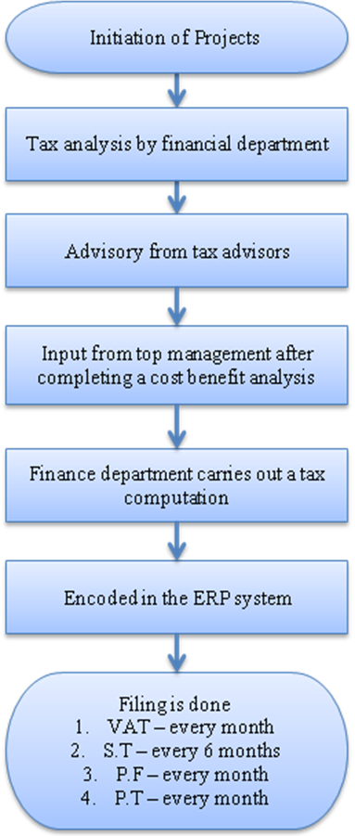

- PROCESS DESCRIPTION
- Every project begins with tax analysis ( which tax scheme should be chosen , with or without MODVAT). This is carried out by the finance department.
- Appointed tax advisors will provide advice to the finance department on tax analysis.
- The top management will carry out a cost benefit analysis and offer their valuable input such as customer pricing, suggesting a well protected scheme, schemes used by competitor, schemes that are prevailing in the industry etc.
- The finance department will do computation after receiving all the inputs.
- After the computation is done, it is encoded in the ERP system.
- Filing is done:
- VAT – every month
- Service Tax – every 6 months
- P.F – every month
- P.T – every month
As of now, VBHC does not require FDI compliance as VBHC does not have FDI investment within the required limit. Later, if investments through FDI are within the required limit. VBHC will do FDI compliance.

- EFFECIENCY MEASURES AND EFFECTIVENESS MEASURES
Efficiency Measures:
Effectiveness Measures:
- Number of non compliance
- Total tax paid as a % of top line.

- RISK ASSOCIATED WITH THE PROCESS
If the company does not follow all the regulations, there might be issues with the financial legalities further into the project.

- FORMATS FOR MAINTAINING RECORDS GENERATED IN THE PROCESS

- RECORDS

