APPROVALS, RESOLUTIONS AND FILING OF FORMS WITH ROC

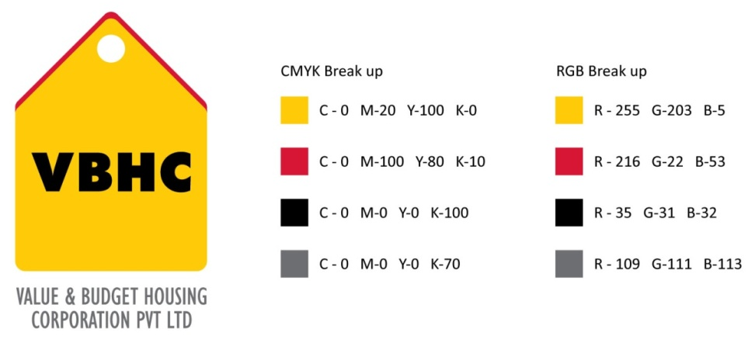
Document Control No : VBHC/LEG/P/05

Revision No : Rev 1.0

Date of Revision : 31st August 2013

 | Name/Designation | Signature | Date
Written By
Reviewed By
Approved By

HISTORY OF REVISIONS

Revision No. | Revision Date | Chapter/clause no.  & text affected | Reason for Revision

TABLE OF CONTENTS
SL No. | CONTENTS | PAGE NO.
1. | Purpose | 1
2. | Process Trigger | 1
3. | Scope and Application | 1
4. | Process Owner  5. | 1
5. | Successor and Predecessor | 1
6. | Responsibilities & Authorities | 2
7. | Definitions and Abbreviations | 2
8. | Process Flow Chart | 3
9. | Process Description | 4
10. | Efficiency measures and effectiveness measures | 5
11. | Risk associated with the process | 6
12. | Formats for maintaining records | 6
13. | Records | 7
14. | Annexure 1 | 8

APPROVALS, RESOLUTIONS AND FILING OF FORMS WITH ROC

- PURPOSE
To pass a resolution in a systematic manner, by conducting meetings or passing circular resolutions so as to obtain approvals from the board and file forms with ROC.

- PROCESS TRIGGER
The process is triggered when the approval from the board is required for passing a resolution.
This may require conducting the following meetings:
- Board Meetings : Every quarterly at Board level
- General Meetings : Annually for all shareholders
- Extraordinary General Meetings: When an approval is required immediately and cannot be postponed till next Annual General Meeting.
- Audit Committee Meetings: Quarterly at Board level
- Land Committee Meetings :Board level ( when required )

- SCOPE AND APPLICATION
Applicable to all resolutions to be approved by the board, all meetings conducted and filing of forms with the ROC.
- PROCESS OWNER
Legal– Head
- PREDECESSOR AND SUCCESSOR PROCESSES
NONE

- RESPONSIBILITY AND AUTHORITY
Preparation of circular resolution and mailing to all members: Legal Department
Organizing and conducting board meetings: Legal Department
To oversee entire meeting process from beginning till end: Legal Head
Filing of Forms: Legal Department
Certification after board approval: Company Secretary
- DEFINITIONS & ABBREVIATIONS
  - DSE- Digital Signature
  - ROC- Registrar of Companies

- PROCESS FLOW CHART
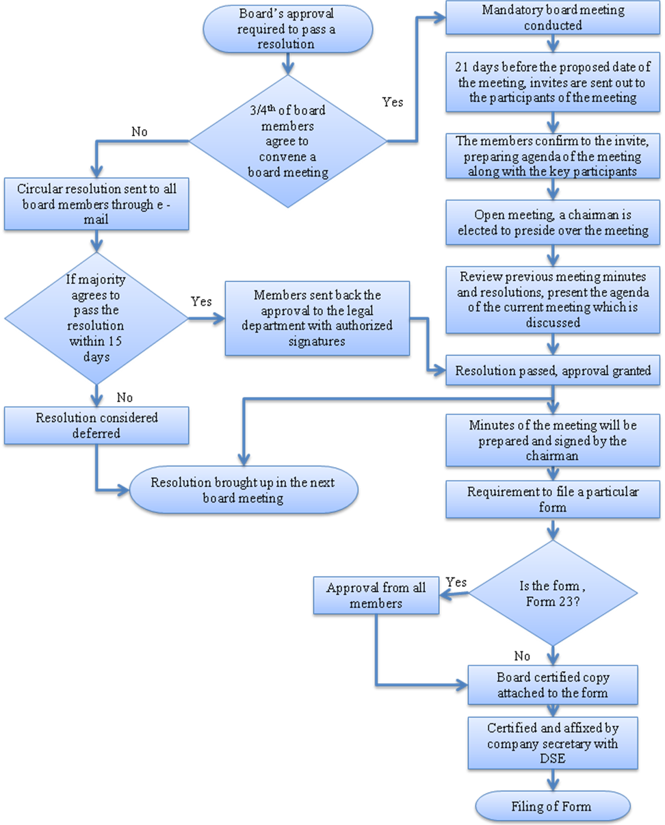

9. PROCESS DESCRIPTION
- In order to pass a resolution, the board has to approve. This is done by conducting a board meeting or passing a circular resolution.
- In order to conduct a meeting, 3/4th of the members have to agree to conduct meeting for passing the resolution.
- If ¾ members don’t agree, a circular resolution is sent by the legal department to all the members via mail.
- If majority agree to pass the resolution within 15 days, it is sent back approved with authorized signatures of all members. If majority does not pass the resolution within 15 days, it is considered deferred.
- In case of the majority of the board members agreeing to conduct a meeting, the same is held as per 9.6 below.
- Conduct of a meeting
    - 21 days before the proposed date of the meeting, formal invites are sent to all the selected members. Along with the invite, the confirmed date, time and venue is mentioned.
    - If the members themselves do not confirm that they will be attending the meeting, the legal department has to do a follow up.
    - The legal department develops the agenda together with key participants in the meeting. The agenda should entail all the activities that are necessary to reach the desired outcome. The agenda should be organized and well structured.
    - The quorum of the meeting is one third or three members, whichever is larger. One investor nominee director or promoter director must be present.
    - The legal head welcomes all the members in attendance and presides over the election of a chairman of the meeting.
    - The Legal head reviews the previous minutes of the meeting and the resolutions that were passed. He further presents the agenda of the current meeting.
The election of a chairman for the meeting, leave of absence and confirmation of minutes of the previous meeting are mandatory in every meeting.
    - The legal head oversees conduct of the meeting. He has to ensure that the meeting is keeping on target of attaining a particular result; he also has to ensure equal participation from all the members. Each member should be given an opportunity to express his views. During the meeting the legal department has to constantly evaluate the meeting, maintain the time and record the meeting.
    - The agenda is discussed and the same is passed after the approval from the majority. Resolution is passed, which is to be documented by the legal department.
    - The vote of thanks is proposed
    - Minutes of the meeting are prepared and the same is printed and signed by the chairman of the meeting.
- In both cases, that is if the resolution is passed through circular resolution or through a board meeting, the resolution is brought up in the next board meeting.
- On obtaining the approval from the board , particular forms need to be filed
    - If the form is Form 23, then the shareholders also have to approve. Other forms only need approval of the board members.
    - A board certified copy is attached to the form.
    - It is then certified by the company secretary with a DSE.
    - Form is filed.
- EFFECIENCY MEASURES AND EFFECTIVENESS MEASURES
Efficiency Measures:
- Time Management
- Proper filing and documentation of agenda, minutes of meeting and resolutions passed.
- Filing of forms have to be carried out in stipulated time
Effectiveness Measures:
.
- RISK ASSOCIATED WITH THE PROCESS

- FORMATS FOR MAINTAINING RECORDS GENERATED IN THE PROCESS

Formal invite send to the members for the meeting.
Minutes of the meeting

FORMS TO BE FILED WITH ROC
FORM NO | PURPOSE | REMARKS
Form 2 | Allotment of shares | To be filed within 30 days
Form 5 | This is filed for various reasons:  - Increase in capital  - Reclassification of capital  - Subdivision of Shares  - Reduction of Capital
Form 8 | Loan taken from bank on mortgage of property
Form 20B | Annual Returns | To be filed annually
Form 23 | To pass resolutions both ordinary and special  Special resolutions :  - Member resolutions  - Appointment of auditors  - Allocation of articles | To be filed within 30 days
Form 23 AC | Balance Sheet | To be filed annually
Form 23ACA | Profit and Loss Statement | To be filed annually
Form 32 | Appointment and resignation of directors. | To be approved by the board within 30 days. If it is not approved, penalty has to be paid to the CLB.
Form 66 | Compliance to Secretarial audit | To be filed annually
Form FCGPR | Shares to NRI | Filed within 30 days after receipt of funds. If not filed, then the funds have to be returned back.
Form FCTRS | Transfer to NRI | To be filed within 30 days after receipt along with a stamp duty  ( 0.25% of consideration)

- RECORDS

ANNEXURE I

Name of Format | Code
Formal invite send to the members for the meeting | VBHC/LEG/F/01
Minutes of the meeting | VBHC/LEG/F/02

