MEASUREMENT, CERTIFICATION AND PAYMENT

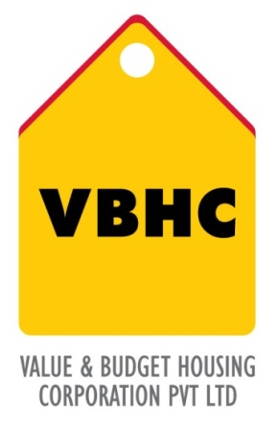
Document Control No : VBHC/OPE/P/05
Revision No : Rev 1.1
Date of Revision : 31st August 2023

 | Name/Designation | Signature | Date
Written By | Shivaprasad
Reviewed By | Kumar GVS

HISTORY OF REVISIONS

Revision No. | Revision Date | Chapter/clause no.  & text affected | Reason for Revision

TABLE OF CONTENTS
SL No. | CONTENTS | PAGE NO.
1. | Purpose | 1
2. | Process Trigger | 1
3. | Scope and Application | 1
4. | Process Owner  5. | 1
5. | Successor and Predecessor | 1
6. | Responsibilities & Authorities | 1
7. | Definitions and Abbreviations | 1
8. | Process Flow Chart | 2
9. | Process Description | 3
10. | Efficiency measures and effectiveness measures | 3
11. | Risk associated with the process | 3
12. | Formats for maintaining records | 4
13. | Records | 4

MEASUREMENT, CERTIFICATE AND PAYMENT

- PURPOSE
To Process the measurement, ceritification and payment to contractors for the work done.

- PROCESS TRIGGER
The process is triggered once an particular item of work is completed.
- SCOPE AND APPLICATION
All VBHC projects
- PROCESS OWNER
Head: Operation

- PREDECESSOR AND SUCCESSOR PROCESSES
Predecessor: Site Coordination (P29, PMC)
Successor: Contract Management (P26,P&C )

- RESPONSIBILITY AND AUTHORITY
- Measurement of Quantities of work done : Site Engineers
- Preparation of Measurement books : Site Engineers
- Rechecking of Measurements : Billing Manager
- Approval of R.A bills: AGM and Finance Department
- Release of Payment : Finance Department

- DEFINITIONS & ABBREVIATIONS
- PROCESS FLOW CHART
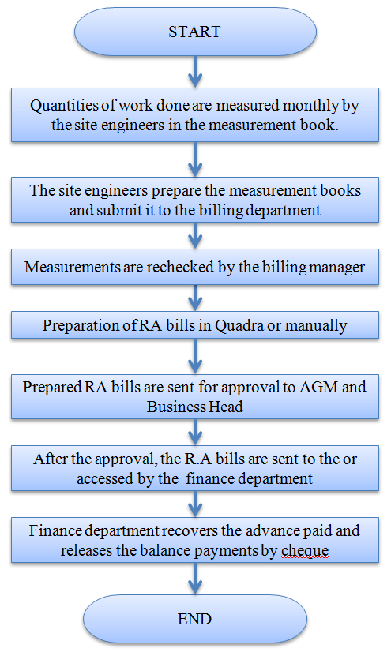

- PROCESS DESCRIPTION
  - The quantities of work done are measured by the Site engineers monthly and entered in the measurement books which are specific to VBHC.
  - The site engineers prepares the measurement books and submit it to the billing department,
  - The measurements are completely rechecked and verified on site or else with reference to working drawing by the billing manager. In the case of any hold up or issues with the quality, a debit note is raised against the contractor.
  - After verification the billing department prepares the RA bills in Quadra. If Quadra is not initially installed, the measurement books are sent to the contracts department in the head office. The contracts department computes the RA bill.
  - Prepared RA bills are sent for approval to AGM and Business Head. The AGM or Business head can recheck the bills. They have the authority to hold up the bills due to any reason.
  - After the approval , the R.A bills are accessed by the finance department. In the case where Quadra is not installed, then the contracts department sends the bills to the finance department.
  - Finance department recovers the advances paid and releases the balance payments by cheque.

10. EFFECIENCY MEASURE AND EFFECTIVENESS MEASURE
Efficiency Measures:
Ensuring rechecking of measurements
Effectiveness Measures:
- RISK ASSOCIATED WITH THE PROCESS
If proper measurement and billing is not carried out, it could lead to financial losses.

- FORMATS FOR MAINTAINING RECORDS GENERATED IN THE PROCESS
RA Bills generated through Quadra

13. RECORDS
Measurement Books

