HANDOVER TO CUSTOMERS

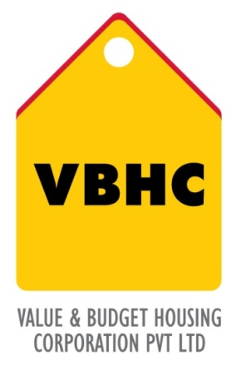
Document Control No : VBHC/PMC/P/05
Revision No : Rev 1.1
Date of Revision : 31st August 2023

 | Name/Designation | Signature | Date
Written By | Shivaprasad
Reviewed By | Kumar GVS

HISTORY OF REVISIONS

Revision No. | Revision Date | Chapter/clause no.  & text affected | Reason for Revision

TABLE OF CONTENTS
SL No. | CONTENTS | PAGE NO.
1. | Purpose | 1
2. | Process Trigger | 1
3. | Scope and Application | 1
4. | Process Owner  5. | 1
5. | Successor and Predecessor | 1
6. | Responsibilities & Authorities | 1
7. | Definitions and Abbreviations | 1
8. | Process Flow Chart | 2
9. | Process Description | 3
10. | Efficiency measures and effectiveness measures | 3
11. | Risk associated with the process | 3
12. | Formats for maintaining records | 4
13. | Records | 4
14. | Annexure I | 5

HANDOVER TO CUSTOMERS

- PURPOSE
To handover the apartment to the customer.

- PROCESS TRIGGER
The process is triggered once the property is registered and after the internal pre-delivery inspections are carried out.
- SCOPE AND APPLICATION
All VBHC projects

- PROCESS OWNER
Head : PMC
- PREDECESSOR AND SUCCESSOR PROCESSES
Predecessor : Property Registration (P47, CRM), Internal Pre-Delivery Inspections (P59,Q)
Successor :Post Handover Maintenance (P54,Admin),Demobilize and Closure Report ( P36,OP)

- RESPONSIBILITY AND AUTHORITY
- Handing over the keys: Maintenance Team
- Completing any issues on quality raised by customer: Quality Department

- DEFINITIONS & ABBREVIATIONS

- PROCESS FLOW CHART
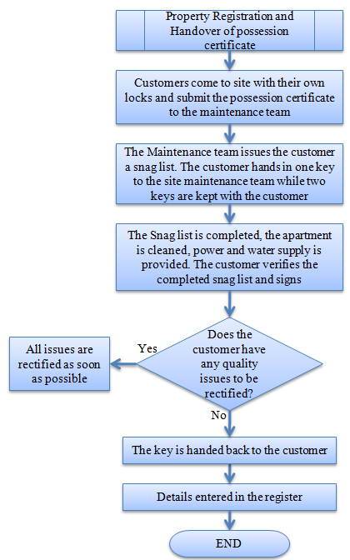

- PROCESS DESCRIPTION
  - The customer once on obtaining the possession certificate can:
- Immediately go to site or
- Schedule his visit his with the site team
- The customer can go to site without any prior appointment.
The customer submits the possession certificate to the site admin team. The customer brings his own lock.
  - On receiving the possession certificate from the customer, the maintenance department hands over a snag list to the customer.
  - One key of the lock to the apartment is kept with the site maintenance team till the snag list is completed. Once the snag list is completed, the apartment is cleaned, power and water supply is provided and is ready to be occupied by the customer. The customer verifies if all the tasks in the snag list have been completed. The customer signs on the snag list to certify that all the works have been completed.
  - If even after all the snag lists have been completed, if the customer finds any issues regarding the quality, all the issues are immediately brought to the notice of the quality team for rectification.
  - After all the rectification work is done, the last key is handed over to the customer.
  - The handover is recorded in the hand over register.
10.0 EFFECIENCY MEASURE AND EFFECTIVENESS MEASURE
Efficiency Measures: Time taken to complete the snag list.
Effectiveness Measures :
- RISK ASSOCIATED WITH THE PROCESS

- FORMATS FOR MAINTAINING RECORDS GENERATED IN THE PROCESS
Register for handover

- RECORDS
ANNEXURE I.
Name of Format | Code
Register for Handover | VBHC/PMC/F/10

