CORRECTIVE AND PREVENTIVE ACTIONS

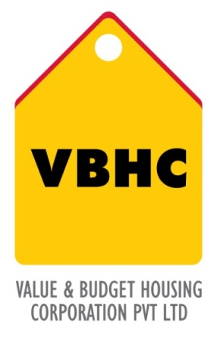
Document Control No : VBHC/QMS/P/05
Revision No : Rev 1.1
Date of Revision : 31st August 2023

 | Name/Designation | Signature | Date
Written By | Ramesh
Reviewed By | Nagesh
Approved By | Kumar GVS

HISTORY OF REVISIONS

Revision No. | Revision Date | Chapter/clause no.  & text affected | Reason for Revision

TABLE OF CONTENTS
SL No. | CONTENTS | PAGE NO.
1. | Purpose | 1
2. | Process Trigger | 1
3. | Scope and Application | 1
4. | Process Owner  5. | 1
5. | Successor and Predecessor | 1
6. | Responsibilities & Authorities | 1
7. | Definitions and Abbreviations | 2
8. | Process Flow Chart | 3
9. | Process Description | 4
10. | Efficiency measures and effectiveness measures | 6
11. | Risk associated with the process | 6
12. | Formats for maintaining records | 6
13. | Records | 6
14 | Annexure I | 7

CORRECTIVE & PREVENTIVE ACTIONS

- PURPOSE
To establish and outline the process to ensure non-conformance/defects, identify/recognize scope for potential non-conformance/problems, analyze root causes, plan, implement and evaluate corrective/preventive actions.

- PROCESS TRIGGER
This process triggers when any NC’s/defect is are identified during the audits or any other instance.

- SCOPE AND APPLICATION
This procedure applies to all departments and all processes of the QMS of VBHC

- PROCESS OWNER
Management Representative

- PREDECESSOR AND SUCCESSOR PROCESSES
Predecessor Process: Internal audits, Non conformance reporting,
Successor Process: Management Review Meetings

- RESPONSIBILITY AND AUTHORITY
- Identification of any deficiencies that could affect the quality: Any personnel working directly and indirectly on the project
- Proposing Corrective/Preventive Action : Functional Head
- Approving the Corrective/Preventive action proposed : MR
- Documenting all CAR’s/PAR’s and follow up for verification : MR

- DEFINITIONS & ABBREVIATIONS
- NC : Non – Conformance
- MR : Management Representative
- QMS : Quality Management System
- CA : Corrective Action
- PA : Preventive Action

- PROCESS FLOW CHART
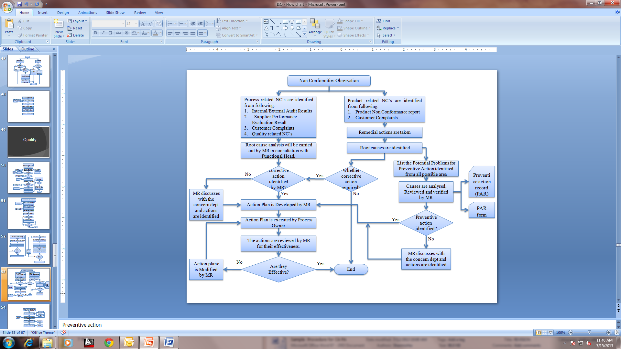

- PROCESS DESCRIPTION
  - Identification of need for taking Corrective/Preventive Actions:
    - Corrective actions are those, which are aimed to eliminate chances of recurrence of non-conformance. Corrective actions generally address the immediate apparent cause on an already observed non-conformance.
    - Corrective actions are taken not only for the non conformance observed and reported during audits (Internal & External), but also against any non conformance observed during project activities, complaints received from interested parties including legal authorities/public in general/ client vendor performance evaluation etc.
    - Preventive actions are those which are aimed to eliminate chances of potential non-conformance. Preventive actions address the root cause of an already observed non-conformance.
    - The non conformance can be raised by any personnel at the site after communication with his immediate superior and immediate corrections are done.
    - Responsibilities for taking Corrective/Preventive actions are assessed/analysed by concerned department head/Process Owner.
    - If the NC/defect is of a technical nature, experts within/outside shall be consulted by MR.
    - Proposed Corrective/Preventive actions are reported to MR by concerned department head/Process Owner.
  - Planning for Corrective/Preventive actions:
    - The process owner shall review the Non-Conformances reported and find out the immediate apparent cause and the root cause(s) of non-conformities through appropriate analysis of data.
    - The process owner shall propose the CA and PA to address the immediately apparent cause and root cause. The proposed Ca & PA shall be reviewed and approved by MR.
    - Depending upon the nature of the root cause, level of Review Authority is assigned by MR to identify the corrective / preventive actions especially when the root cause may manifest itself in the form of another potential problem.
    - If it is possible then Corrective and/ or Preventive Action shall be taken immediately by the process owner, else a date by which the CA / PA will be implemented shall be committed by the process owner.
    - In cases when actions can not be identified, then they are escalated either to TOP Management or cross functional team depending upon the severity of the problem.
    - These analysis of NCR, proposed CA/PA shall be taken up in the management review meeting by MR (in case major resources are required).
  - Corrective / Preventive Action(s) measures may include the following:
      - Revision of working process or method.
      - Revision of responsibilities/ Job Description
      - Identification and addressing Training need.
      - Identification to additional staff/resource requirement.
      - Amendments to Documents.
      - Change of Process to prevent harm to Environment
      - Change of existing unsafe working practice and provide
      - Safe working environment to personnel associated.

  - Implementation of Corrective / Preventive Action:
The Process Owner shall implement the proposed Corrective / Preventive Action(s)
    - The Process Owner shall verify the implementation of Corrective/Preventive action(s) in order to ensure that desired goals are met in case when the action taken is found to be not effective the same shall be referred to the Management Reviewing Meeting for initiating suitable action.
    - MR shall verify the implementation of the Corrective / Preventive Action(s) and close out the non-conformance if the action(s) taken is effective.
  - Distribution & Filing:
    - Corrective and Preventive action reports shall be sent to the Department Heads for verification and record.
    - All Corrective and Preventive Action(s) reports shall be sent to the Management Representative for review and record.

- EFFECIENCY MEASURES AND EFFECTIVENESS MEASURES
Efficiency Measures: Average time taken to close NCs
Effectiveness Measures: Number of repeat NCs

- RISK ASSOCIATED WITH THE PROCESS

- FORMATS FOR MAINTAINING RECORDS GENERATED IN THE PROCESS
Preventive Action & Corrective Action Request (PAR)
Preventive Action & Corrective Action Tracking Log

- RECORDS
Corrective & Preventive action record

ANNEXURE I
Name of Format | Code
Corrective Action and Preventive action Request | VBHC/QMS/F/01
Corrective Action and Preventive action Log | VBHC/QMS/F/02

