**MAINTAIN AND UPDATE WEBSITE**

**Document Control No** : VBHC/S&M/P/05

**Revision No**  : Rev 1.1

**Date of Revision** : 1st April 23

|  |  |  |  |
| --- | --- | --- | --- |
|  | ***Name/Designation*** | ***Signature*** | ***Date*** |
| ***Written By*** | ***Rajeesh MR*** |  |  |
| ***Reviewed By*** | ***Siddharth Gautam*** |  |  |
|  |  |  |  |

**HISTORY OF REVISIONS**

|  |  |  |  |
| --- | --- | --- | --- |
| **Revision No.** | **Revision Date** | **Chapter/clause no.**  **& text affected** | **Reason for Revision** |
|  |  |  |  |
|  |  |  |  |
|  |  |  |  |
|  |  |  |  |
|  |  |  |  |
|  |  |  |  |
|  |  |  |  |
|  |  |  |  |
|  |  |  |  |
|  |  |  |  |
|  |  |  |  |
|  |  |  |  |
|  |  |  |  |
|  |  |  |  |
|  |  |  |  |

**TABLE OF CONTENTS**

|  |  |  |
| --- | --- | --- |
| **SL No.** | **CONTENTS** | **PAGE NO.** |
| 1. | Purpose | 1 |
| 2. | Process Trigger | 1 |
| 3. | Scope and Application | 1 |
| 4. | Process Owner  5. | 1 |
| 5. | Successor and Predecessor | 1 |
| 6. | Responsibilities & Authorities | 1 |
| 7. | Definitions and Abbreviations | 2 |
| 8. | Process Flow Chart | 2 |
| 9. | Process Description | 2 |
| 10. | Efficiency measures and effectiveness measures | 4 |
| 11. | Risk associated with the process | 4 |
| 12. | Formats for maintaining records | 4 |
| 13. | Records | 4 |

**MAINTAIN AND UPDATE WEBSITE**

1. **PURPOSE**

To maintain and update the company’s marketing website when there are changes that need to be added in order to promote marketing activities

1. **PROCESS TRIGGER**

The process is an ongoing process and when a new project is launched.

1. **SCOPE AND APPLICATION**

All VBHC marketing websites. (VBHC has one main marketing website and five micro sites.)

1. **PROCESS OWNER**

Head – Sales & Marketing

1. **PREDECESSOR AND SUCCESSOR PROCESSES**

Marketing Department

1. **RESPONSIBILITY AND AUTHORITY**

Identification of updates to be carried out: Marketing and Sales Head

Appointment of Consultants: Marketing Manager

Approval of any changes in the website: Marketing Manager

All approvals: Marketing Head

1. **DEFINITIONS & ABBREVIATIONS**
2. **PROCESS FLOW CHART**

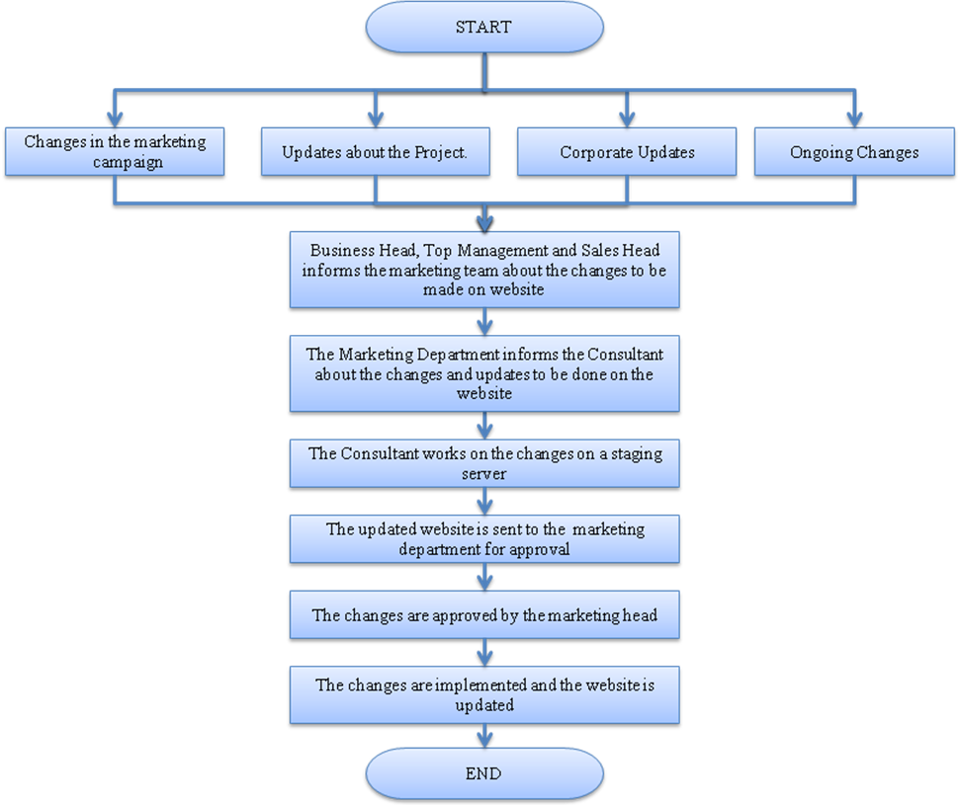

1. **PROCESS DESCRIPTION**
   1. Any of the following changes require the website to be updated

* Campaign related changes: When a new project is launched, any changes in order to promote the project.
* Any promotions
* Any offers being offered to the customers
* Pop-up Banners
* Micro site
* Launch Banners
* Project Updates
* Introduction of a new project
* Introduction of a new phase
* Any launch activities
* Details about the project:
  + Location Map
  + Master Plans
  + Floor Plans
  + Amenities and Services
  + Construction Progress (pictures and text, updated on a monthly basis)
  + Model Apartment Pictures
* Corporate Updates
* Changes in the Mission/Vision Updates
* Messages from Top Management
* Change in the Corporate Structure
* Awards and Recognition
* Changes in Company Policy
* Any newspaper or magazine articles about the company
* Ongoing Updates:

The sales and marketing team strive to maintain and update the website constantly in order to promote projects and the company.

* Interactive media e.g. Virtual Tour
* Improving instant Communication with the sales team
* To make booking more easy
* Price Changes
* Web Site content management
* Updating website based on suggestions from social networking sites and social forums.

9.2 When there are these changes to be made in the website, the marketing team is informed about it by the business heads, top management or the sales head.

9.3 The marketing department will analyze the changes and inform the consultant to update these changes on the website.

9.4The consultant does the updates on a staging server and not on the live website.

9.5 The changes are sent to the marketing department which is approved by the marketing head.

9.6 After the approval, the consultant will update the changes in the live website.

9.7 A monthly review is carried out by the marketing team, if there is any information to be added or removed; it is approved by the Marketing.

1. **EFFECIENCY MEASURES AND EFFECTIVENESS MEASURES**

Efficiency Measures:

Effectiveness Measures:

1. **RISK ASSOCIATED WITH THE PROCESS**
2. **FORMATS FOR MAINTAINING RECORDS GENERATED IN THE PROCESS**
3. **RECORDS**