MARKETING COLLATERALS

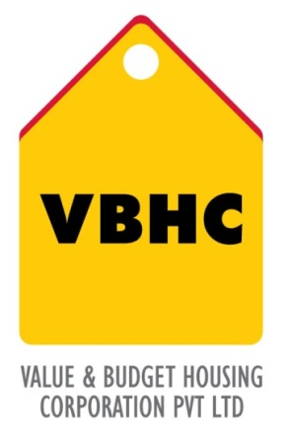
Document Control No : VBHC/DES/ /06
Revision No : R0

Issued date :

Record &Documents : a. Site plan
b. Area statement
c. Masterplan
d. Unit plans
e. perspectives.

 | Name/Designation | Signature | Date
Reviewed By | Chakravarthi
Approved By | Siddharth Gowtam

TABLE OF CONTENTS
SL No. | CONTENTS
1. | Purpose
2. | Process Trigger
3. | Scope and Application
4. | Process Owner  5.
5. | Successor and Predecessor
6. | Responsibilities & Authorities
7. | Definitions and Abbreviations
8. | Process Flow Chart
9. | Process Description
10. | Efficiency measures and effectiveness measures
11. | Risk associated with the process
12. | Formats for maintaining records
13. | Records

MARKETING COLLATERALS
- PURPOSE
To create and implement images and graphics to reach and communicate with potential customers to promote sales.

- PROCESS TRIGGER
This process is triggered after the sanction plans are approved.

- SCOPE AND APPLICATION
Applicable to all projects developed by VBHC
- PROCESS OWNER
Project architect

PREDECESSOR AND SUCCESSOR PROCESSES

Predecessor: Sanction Drawings

Successor: Marketing Collaterals

RESPONSIBILITY AND AUTHORITY
Responsibility: Design Head
Authority: Operation Head

DEFINITIONS & ABBREVIATIONS

PROCESS FLOW CHART

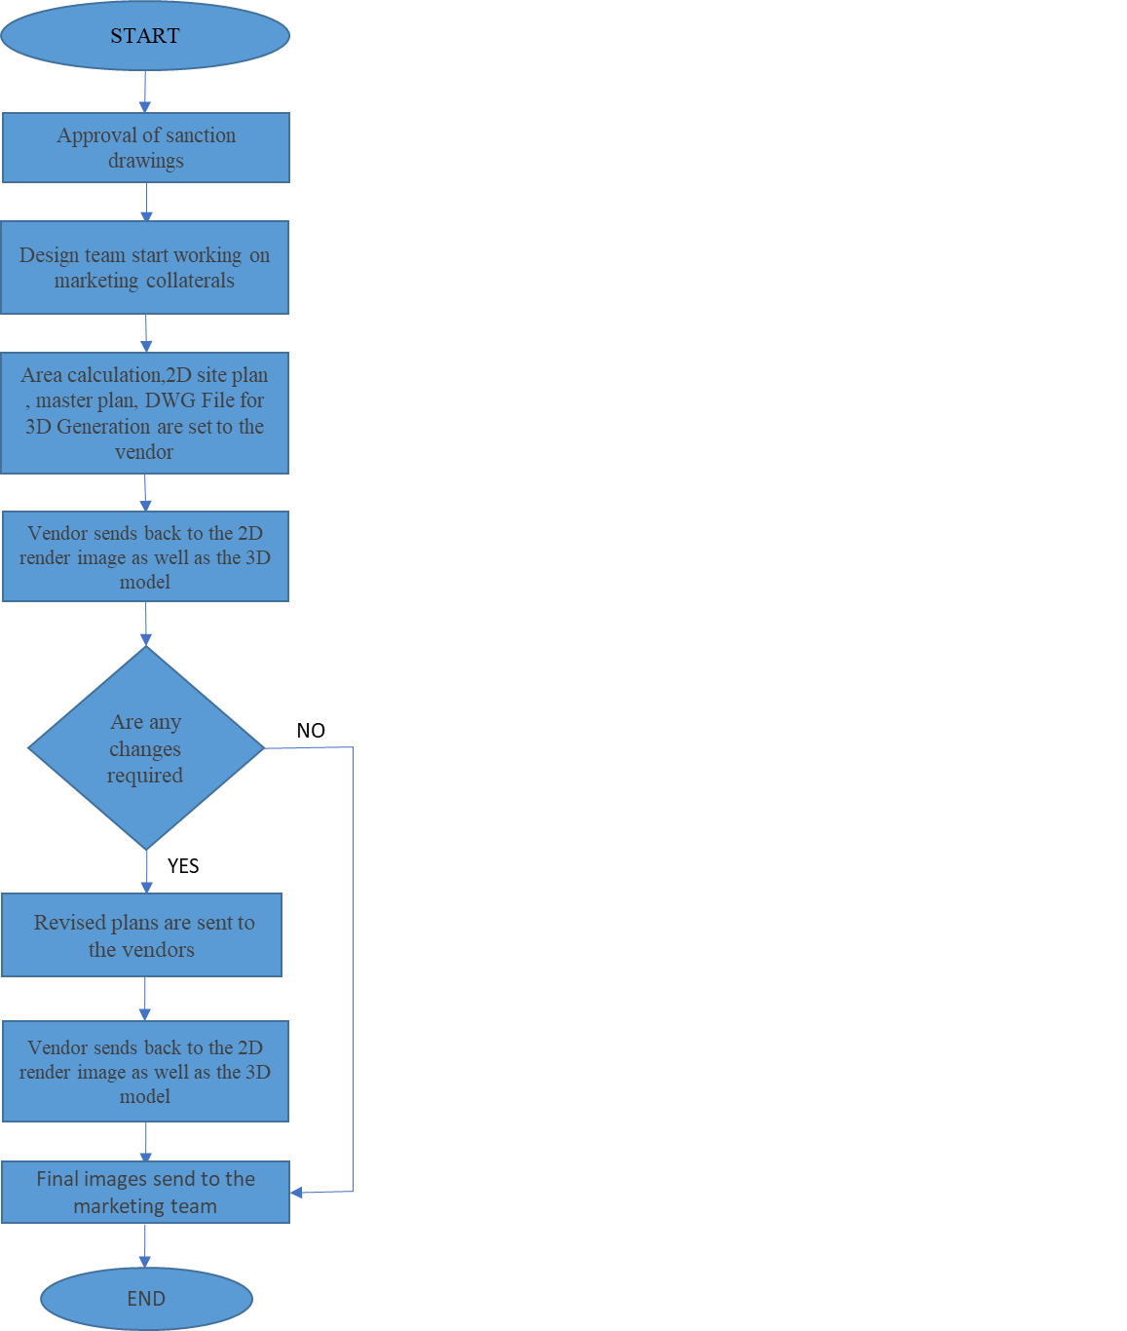

9. PROCESS DESCRIPTION
9.1 Once the sanction plans are approved, the design team starts working on the marketing collaterals such as area calculations, 2D site plan, 2D plans (block and cluster).
9.2 All the prepared plans along with a DWG file (for 3D modeling) are sent to the vendor.
9.3 The vendor sends back all rendered 2D and 3D images to the design team.
9.4 If the project architect does not require any changes to be carried out, the images are finalized and sent to the marketing department.
9.5 In cases where there are changes to be made due to changes in the design (both architecture and structure), authority feedback, management feedback etc., the project architect will reissue the 2D images, all area calculations, parking plan, orientation etc. All communication is carried out by means of email.
9.6 The vendor sends back the finalized 2D images as well as 3D models.
9.7 The final images are sent by the project architect to the marketing department.

EFFECIENCY MEASURES AND EFFECTIVENESS MEASURES
Efficiency Measure:
Effectiveness Measure:

RISK ASSOCIATED WITH THE PROCESS
There might be an overflow of work or unsatisfactory results, in this case, the design department should consider a second choice of consultant for the various works.

FORMATS FOR MAINTAINING RECORDS GENERATED IN THE PROCESS

13. 0 RECORDS
a. Site plan
b. Area statement
c. Masterplan
d. Unit plans
e. perspectives.

