CORPORATE BUDGET

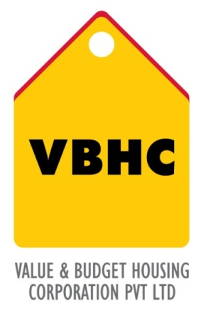
Document Control No : VBHC/FIN/P/06
Revision No : Rev 1.0
Date of Revision : 31st August 2013

 | Name/Designation | Signature | Date
Written By
Reviewed By
Approved By

HISTORY OF REVISIONS

Revision No. | Revision Date | Chapter/clause no.  & text affected | Reason for Revision

TABLE OF CONTENTS
SL No. | CONTENTS | PAGE NO.
1. | Purpose | 1
2. | Process Trigger | 1
3. | Scope and Application | 1
4. | Process Owner  5. | 1
5. | Successor and Predecessor | 1
6. | Responsibilities & Authorities | 1
7. | Definitions and Abbreviations | 1
8. | Process Flow Chart | 2
9. | Process Description | 2
10. | Efficiency measures and effectiveness measures | 4
11. | Risk associated with the process | 4
12. | Formats for maintaining records | 4
13. | Records | 4

CORPORATE BUDGET

- PURPOSE
To estimates finances for a future period and plan corporate operations accordingly.

- PROCESS TRIGGER
This process is triggered at the beginning of every financial year.
3.0 SCOPE AND APPLICATION
Applicable to VBHC as an organization.
- PROCESS OWNER
Finance – Head / Controller

- PREDECESSOR AND SUCCESSOR PROCESSES

- RESPONSIBILITY AND AUTHORITY
Preparation of Corporate Budget: Finance Department
Determining of pay roll costs: HOD’s
Determining of Professional fees: C.F.O or M.D
Determining of Interest Costs: C.F.O
Approval of Corporate Budget: Top Management

- DEFINITIONS & ABBREVIATIONS
- HOD: Head of Department
- CFO: Chief Finance Officer
- CIO: Chief Information Officer
- CEO: Chief Executive Officer
- M.D: Managing Director

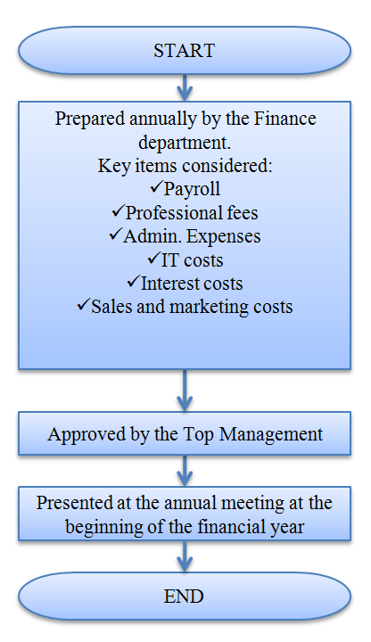
- PROCESS FLOW CHART

- PROCESS DESCRIPTION
- The Corporate Budget is prepared at the beginning of every financial year and is prepared by the Finance department.
- The key items that are considered are :
9.2.1 Payroll costs
- Payroll costs are budgeted based on resources required at the corporate level for the projects.
- The resource requirements is to be determined by the various HOD’s and based on that this will be budgeted.

9.2.2 Professional fees
- Key items of professional fees incurred at the parent company (VBHC) are towards fund raising or towards activity in projects which are yet to be initiated.
- The budgeting of this will be done by the CFO/MD based on the plans for fund raising during the coming year and also by understanding the key activities expected to be undertaken during the year.
- Other consulting assignments/ retainers during the year are determined on a need basis by consulting the various HOD’s and seeking their input

9.2.3 Admin. Expenses
- Admin. Expenses are budgeted based on current rate as most of these expenses are fixed.
- If there is a need for additional offices etc,. this is determined in consultation with admin.

    - IT costs
      - Key items of cost include additional softwares and license renewal costs.
      - The license renewal costs are determined based on number of users while the software costs are based on the decision of the CIO in consultation with the CEO.

9.2.5 Interest costs
- Interest costs are determined based on additional loans expected to be taken at the parent for funding the parent working capital etc.
- This is determined by the CFO based on the cash flows and expected WIP capitalization emanating from the subsidiaries/fixed asset requirements which can be funded out of parent

9.2.6 Sales and Marketing
- Costs towards any project specific marketing are kept minimal.
- Any branding activity which is towards the company as a whole is the parent cost. This is determined by the Marketing head in consultation with the CEO
  - This is approved by the top management and communicated to all the heads of departments.
  - Presented along with the annual financial reports at the beginning of very financial year.

- EFFECIENCY MEASURES AND EFFECTIVENESS MEASURES
Efficiency Measures:
No of days from beginning of the year to finalize the budget
Effectiveness Measures:
More efficient use of Finance resources.

- RISK ASSOCIATED WITH THE PROCESS
- Diverging interpretation of budget categories among various subsidiaries and business units makes consolidation error-prone.
- Lack of clarity and consistency in budgeting procedures, responsibilities and timeline.
- Failure to follow-up and analyze variances
- Inability to deal transparently with intra-period changes to budget assumptions
- Excessive manual processes that create an administrative burden.

- FORMATS FOR MAINTAINING RECORDS GENERATED IN THE PROCESS

- RECORDS

