COMPETENCY MAPPING

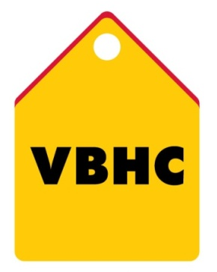

Document Control No : VBHC/HR/P/06
Revision No : Rev1.1
Date of Revision : 01st April 2023

 | Name/Designation | Signature | Date
Written By | Shashidhar Rao
Reviewed By | Kumar GVS

HISTORY OF REVISIONS

Revision No. | Revision Date | Chapter/clause no.  & text affected | Reason for Revision

TABLE OF CONTENTS

SL No. | CONTENTS | PAGE NO.
1. | Purpose | 1
2. | Process Trigger | 1
3. | Scope and Application | 1
4. | Process Owner  5. | 1
5. | Successor and Predecessor | 1
6. | Responsibilities & Authorities | 1
7. | Definitions and Abbreviations | 1
8. | Process Flow Chart | 2
9. | Process Description | 2
10. | Efficiency measures and effectiveness measures | 4
11. | Risk associated with the process | 4
12. | Formats for maintaining records | 4
13. | Records | 4
14. | Annexure I | 4

COMPETENCY MAPPING

- PURPOSE
To identify key competencies for a particular position in an organization and analyze the gaps.
- PROCESS TRIGGER
None
- SCOPE AND APPLICATION
This process is applicable to all positions and employees at VBHC.
- PROCESS OWNER
Head, HR
- PREDECESSOR AND SUCCESSOR PROCESSES
Predecessor Process: None
Successor Process: Recruitment, Performance Management.
- RESPONSIBILITY AND AUTHORITY.
To approve performance achieved: Functional Heads and HODs.
To decide on final performance rating: Functional Heads and HODs.
- DEFINITIONS & ABBREVIATIONS
- KRA: Key Result Area.

1
- PROCESS FLOW CHART

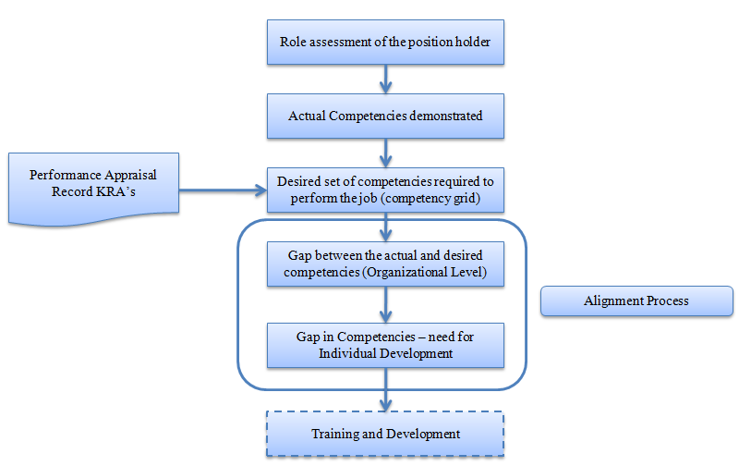

- PROCESS DESCRIPTION
  - The following steps shall be followed in competency Mapping:
  - Role assessment:
    - HR – Head decides the positions for which the competencies need to be mapped.
    - HR – Head identifies the level of hierarchy in the organizational structure. This provides the clarity of organizational structure and defines the relationships between the different posts under consideration. (Reporting authority, subordinates, peers etc.).
2
  - Actual competencies demonstrated:
    - Functional Head identifies the objectives of the function or the department or the unit or section where the position is located.
    - Functional Head identifies the objectives of the role. Why does the position exist? What are the main purposes of the role etc. details and defines the roles and responsibilities of position holder in RASI Matrix.
  - Desired set of competencies required to carry out the job:
    - Functional Head Collects the Key Performance Areas (or KRAs, Tasks, etc.) of the position holder for the last two to three years from the performance appraisal records. Alternately, collects the job descriptions of any of the position to make a list of all tasks and activities to be performed by that position holder and define the competencies/capabilities required to perform them effectively.
  - Gap between Actual and Desired Competencies: (Organizational level & Individual development)
    - Functional Head interviews the position holder to list the Tasks and activities expected to be performed by the Individual. Group them into a set of tasks. There is no rigid rule about the number of tasks. It depends on complexity of the position.
    - AVP, HR interviews the position holder to list the actual knowledge, attitude, skills, and other competencies required for performing the task effectively.
    - Repeat the process with all the position set members.
    - List out the competencies for all the position holders for each task, Edit and finalize. Present it to the Head of the position holder and the position holder for approval and finalization.

3
- EFFECIENCY MEASURES AND EFFECTIVENESS MEASURES
Efficiency Measures:
Effectiveness Measures:

- RISK ASSOCIATED WITH THE PROCESS
If actual competencies are not defined properly it will affect the performance of work assigned to position holder
- FORMATS FOR MAINTAINING RECORDS GENERATED IN THE PROCESS
RASI matrix (roles and responsibilities) – available on server
Organisation structure (project and corporate level) – available in HRMS
List of Competencies
- RECORDS

4
ANNEXURE I
Name of Format | Code
List of Competencies | VBHC/HR/F/08
5

