PRE-CONSTRUCTION HR PLANNING

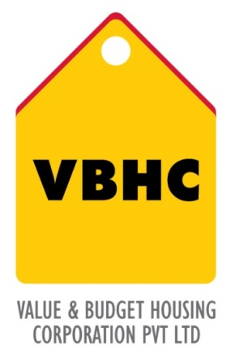
Document Control No : VBHC/OPE/P/06
Revision No : Rev 1.1
Date of Revision : 31st August 2023

 | Name/Designation | Signature | Date
Written By | Shivaprasad
Reviewed By | Kumar GVS

HISTORY OF REVISIONS

Revision No. | Revision Date | Chapter/clause no.  & text affected | Reason for Revision

TABLE OF CONTENTS

SL No. | CONTENTS | PAGE NO.
1. | Purpose | 1
2. | Process Trigger | 1
3. | Scope and Application | 1
4. | Process Owner  5. | 1
5. | Successor and Predecessor | 1
6. | Responsibilities & Authorities | 1
7. | Definitions and Abbreviations | 1
8. | Process Flow Chart | 2
9. | Process Description | 2
10. | Efficiency measures and effectiveness measures | 3
11. | Risk associated with the process | 3
12. | Formats for maintaining records | 3
13. | Records | 3
14. | Annexure 1 | 4
PRE-CONSTRUCTION HR PLANNING

- PURPOSE
To Identify and estimate man-power resource requirement for execution of the project with desired skill sets based on PMS prepared for the project
- PROCESS TRIGGER
This process is triggered when Project Master Schedule for the project is approved by the COO.
- SCOPE AND APPLICATION
This process applies to all VBHC projects and cover planning for human resources to be deployed at the project site on permanent pay roll of VBHC.
- PROCESS OWNER
PMC - Head.
- PREDECESSOR AND SUCCESSOR PROCESSES
Predecessor Process: Project Master Schedule (P30,PMC)
Successor Process: Recruitment (P48,HR)
- RESPONSIBILITY AND AUTHORITY
To prepare HR Schedule : Head – PMC.
- DEFINITIONS & ABBREVIATIONS
- PMS : Project Master Schedule.
- PMC : Project Management.
- HR Planning : Human Resource Planning
- COO : Chief Operating Officer
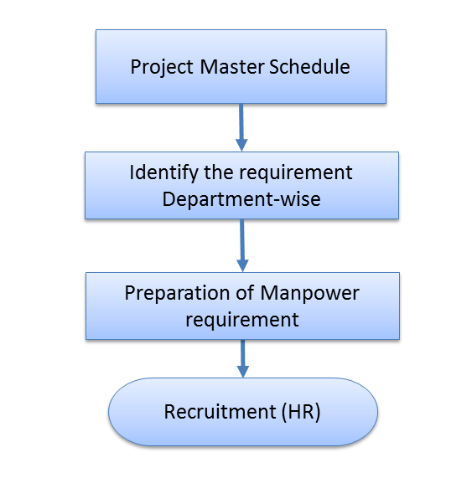
- PROCESS FLOW CHART

- PROCESS DESCRIPTION
- Project Master Schedule: Provides the input for the resource requirement.
- Identify the requirement department wise: PMC shall then estimate total man-power requirement department-wise for the project.
- Preparation of Manpower requirement: The department wise manpower requirement then tabulated (Refer attachment).Which details designation, qualification, experience and expected date of joining of the staff.
- Recruitment: HR department shall then initiate the man-power recruitment as per the inputs.
- EFFECIENCY MEASURES AND EFFECTIVENESS MEASURES
Efficiency Measures: The fresh hiring inputs shall be given to HR department 60days before the actual requirement at site.
Effectiveness Measures:
Number of changes made in HR requirements of a project vis-à-vis the HR plan at pre – construction stage
- RISK ASSOCIATED WITH THE PROCESS
Availability of man-power and availability of desired skill sets.

- FORMATS FOR MAINTAINING RECORDS GENERATED IN THE PROCESS
  - Manpower requirement table:
Sl. No | Designation | Qualification | Experience | Expected date of Joining

- RECORDS

ANNEXURE I
Name of Format | Code
Manpower requirement table | VBHC/OPE/F/04

