POST HANDOVER MAINTENANCE

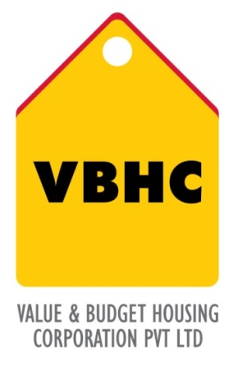
Document Control No : VBHC/PMC/P/06
Revision No : Rev 1.1
Date of Revision : 31st August 2023

 | Name/Designation | Signature | Date
Written By | Shivaprasad
Reviewed By | Kumar GVS

TABLE OF CONTENTS
SL No. | CONTENTS | PAGE NO.
1. | Purpose | 1
2. | Process Trigger | 1
3. | Scope and Application | 1
4. | Process Owner  5. | 1
5. | Successor and Predecessor | 1
6. | Responsibilities & Authorities | 1
7. | Definitions and Abbreviations | 1
8. | Process Flow Chart | 2
9. | Process Description | 2
10. | Efficiency measures and effectiveness measures | 4
11. | Risk associated with the process | 4
12. | Formats for maintaining records | 4
13. | Records | 4
14. | Annexure I | 5

POST HANDOVER MAINTENANCE

- PURPOSE
To ensure proper maintenance of property after the handover of the project to the customers.

- PROCESS TRIGGER
The process is triggered once the property is handed over to the customers

- SCOPE AND APPLICATION
All VBHC projects
- PROCESS OWNER
Head : PMC
- PREDECESSOR AND SUCCESSOR PROCESSES
Predecessor :Handover to Customers (P53,CRM)
Successor : Formation of RWA and Handover Project Maintenance (P16,Leg),END

- RESPONSIBILITY AND AUTHORITY
- Charting out activities: Operations Department
- Purchase of all required items : Purchase Department

- DEFINITIONS & ABBREVIATIONS

- PROCESS FLOW CHART
Handover of apartment to owners
END
If there are any complaints: The customers report to maintenance office
If any complaints are very common and frequent , the quality team is informed to find a long term solution
Daily Maintenance
- Housekeeping
- Plumbing
- Electrical
- Gardening

Appointment of in house maintenance team

Setting up of maintenance office

- PROCESS DESCRIPTION
  - Authorization of possession of the VBHC home is given to the owner i.e. the apartments are handed over.
  - Applicants and vendors are interviewed and selected in order to form an in house maintenance team. This is carried out when the projects near completion.
  - A maintenance office is set up.
  - Maintenance is done on a daily basis or carried out when a customer raises a complaint. The customer fills in a form stating the nature of the complaint. The complaint is immediately registered and rectified immediatetly.
  - Maintenance that is carried out on a daily basis:
- Housekeeping
  - Waste is removed from each home.
  - Cleaning of: Corridor, Lifts, Electric Shafts, Fire hydrants, Staircase and Common Areas.
  - Segregation of Waste into wet and dry waste.
- Plumbing
  - Water levels in tanks are checked
  - Checking for any leakage is carried out
  - Any complaints are attended to immediately
- Electrical
  - All common lights are checked
  - All common electrical fixtures are checked.
  - Lift lights are checked
- Gardening
  - Gardens are cleaned on a daily basis
  - Removal of common waste
  - If there are common complaints, the quality team will be informed about them in order to find out a long term solution.

10.0 EFFECIENCY MEASURE AND EFFECTIVENESS MEASURE
Efficiency Measures:
- Appointment of trained personnel for the in house team
- Mean time for complaint resolution
Effectiveness Measures:
- RISK ASSOCIATED WITH THE PROCESS
If proper maintenance not carried out, there will be an increase in complaints.

- FORMATS FOR MAINTAINING RECORDS GENERATED IN THE PROCESS
Maintenance Department Service Report

- RECORDS
Daily maintenance Register

ANNEXURE I.
Name of Format | Code
Maintenance Department  Service Report | VBHC/PMC/F/06
Plumbing Job Sheet | VBHC/PMC/F/07
Civil Job Sheet | VBHC/PMC/F/08
Electrical Job sheet | VBHC/PMC/F/09

