CONTROL OF NON CONFORMING PRODUCT

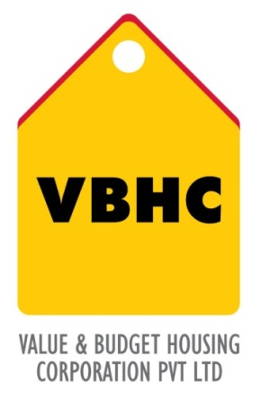
Document Control No : VBHC/QMS/P/06
Revision No : Rev 1.1
Date of Revision : 31st August 2023

 | Name/Designation | Signature | Date
Written By | Ramesh
Reviewed By | Nagesh
Approved By | Kumar GVS

HISTORY OF REVISIONS

Revision No. | Revision Date | Chapter/clause no.  & text affected | Reason for Revision

TABLE OF CONTENTS
SL No. | CONTENTS | PAGE NO.
1. | Purpose | 1
2. | Process Trigger | 1
3. | Scope and Application | 1
4. | Process Owner  5. | 1
5. | Successor and Predecessor | 1
6. | Responsibilities & Authorities | 1
7. | Definitions and Abbreviations | 2
8. | Process Flow Chart | 2
9. | Process Description | 3
10. | Efficiency measures and effectiveness measures | 5
11. | Risk associated with the process | 5
12. | Formats for maintaining records | 5
13. | Records | 5
14 | Annexure I | 6

CONTROL OF NON CONFORMING PRODUCT

- PURPOSE
This procedure is to describe the non-conformance reporting system, instruct its users on the proper method of using non-conformance report (NCR) forms, and provide a benchmark by which to measure project quality.

- PROCESS TRIGGER
This process is triggered on discovery of any non-conforming item.

- SCOPE AND APPLICATION
All processes under VBHC’s QMS. It encompasses all materials and services used in the construction of the project.
- PROCESS OWNER
Management Representative (MR)

- PREDECESSOR AND SUCCESSOR PROCESSES
Predecessor: None
Successor : CAPA;MRM

- RESPONSIBILITY AND AUTHORITY
- Initiation of NCR:
  - Members of the contractor's, subcontractor’s, or supplier’s QC organization
  - Field quality or resident engineers
  - Members of the Project management team.
  - VBHC corporate office employees
- Documentation of NCR : Quality department
- Re-inspection after disposition : Quality department

- DEFINITIONS & ABBREVIATIONS
- NCR – Non conformance report

- PROCESS FLOW CHART
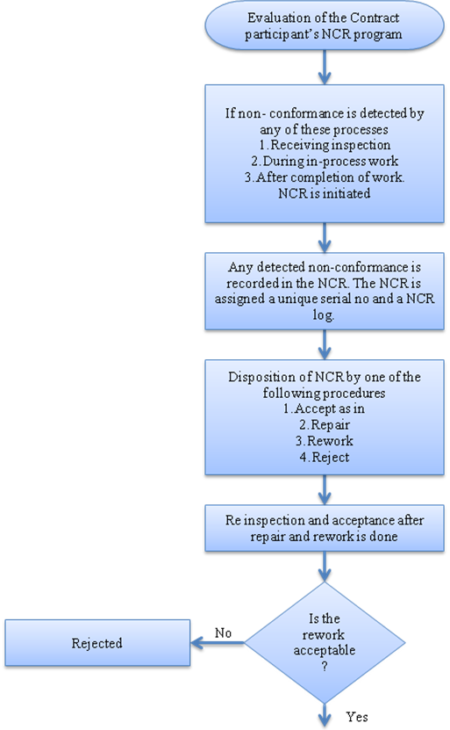

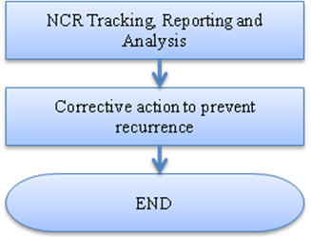

- PROCESS DESCRIPTION
9.1 The Quality manager shall evaluate the contractor quality plan submittals, and establish that the contractor has delineated a satisfactory system for identifying and controlling non-conforming items.
9.2 An NCR is initiated if non-conformances are identified during any of the following stages of work:
- Receiving inspection—Non-conformances identified during the receipt of materials or products that have been delivered to the job site, or to a storage location, which are identified by the contract as being within the criteria for payment.
- During in-process work activities—Non-conformances discovered during in-process work activities that are not immediately correctable by further prescribed processing and within the authority of the Statement of Work.
- After completion of the work—All non-conformances discovered after the completion of work activities and related inspections and tests. Non-conformances discovered after acceptance will also be reported and corrected.

An NCR can be initiated by any of the following participants:
- Members of the contractor's, subcontractor’s, or supplier’s QC organization
- Field quality or resident engineers
- Members of the quality department.
- Operations team member
- Officials visiting from corporate office
9.3 Immediately after identifying a non-conformance, the individual that detected the discrepancy shall initiate an NCR. It is important to describe in detail, the nonconforming condition, and include sketches and photos at every opportunity. Once written, the NCR shall be forwarded to the quality department and the management representative. The NCR shall be raised in standard format no. VBHC/ F/ 001/07/ 708
The quality department will assign the NCR a unique serial number and a NCR tag which serve to identify and track NCRs. The Quality department shall also record the person who shall be responsible to take correction/CAPA. The NCR shall be sent to the responsible person by the Quality department.
9.4 Each NCR shall include a description of its disposition. The description shall identify and document the action or procedure selected to correct the noted deficiency. Disposition can be carried out by:
- Accept-As-Is: Field condition, while not in conformance to the approved design, that is acceptable as installed or constructed for intended use. No further field action is required.
- Repair: The responsible engineer defines a repair procedure that will ultimately produce a product that is based on an acceptable alternate design.
- Rework: When neither “accept-as-is” or “repair” is supported by engineering analysis, the nonconforming item is rejected, and must be reworked to meet the approved design requirements.
- Reject : The action taken to eliminate/physically remove from site a non-conforming item found unsuitable for its specified use.
  - Upon completion of the required rework or repair dispositions, the quality department shall re-inspect the item(s) to establish conformance to the applicable requirements, including the NCR disposition.
  - If the item is found acceptable, the quality department documents the acceptance by signing and dating the original NCR. If the item is found unacceptable after rework or repair, the disposition is updated to “reject.”
  - When CAPA is deemed necessary, a copy of the NCR will be routed to the organization responsible for control of the activity during which the non-conformance was identified to prevent recurrence of the non-conformance were implemented.

- EFFECIENCY MEASURES AND EFFECTIVENESS MEASURES
Efficiency Measures:
- Timely reporting of non- conformances
- Documentations of NCR
Effectiveness Measures: Average number of snags in completed flats (lesser the better)

- RISK ASSOCIATED WITH THE PROCESS

- FORMATS FOR MAINTAINING RECORDS GENERATED IN THE PROCESS
- Non-Conformance Report (NCR)
- Non-Conformance Report Log

ANNEXURE I
Name of Format | Code
Non-Conformance Report (NCR) | VBHC/QMS/F/08
Non-Conformance Report Log | VBHC/QMS/F/09

