RFI FROM SITE

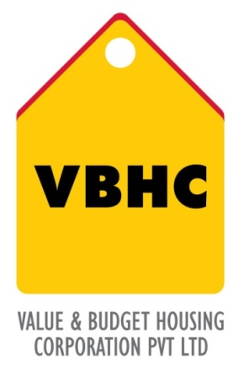
Document Control No : VBHC/DES/ /07
Revision No : Rev 1.1
Date of Revision : 31st August 2023

 | Name/Designation | Signature | Date
Written By | Podapati Dharani
Reviewed By | Chakravarthi
Approved By | Kumar GVS

TABLE OF CONTENTS
SL No. | CONTENTS | PAGE NO.
1. | Purpose | 1
2. | Process Trigger | 1
3. | Scope and Application | 1
4. | Process Owner  5. | 1
5. | Successor and Predecessor | 1
6. | Responsibilities & Authorities | 1
7. | Definitions and Abbreviations | 1
8. | Process Flow Chart | 2
9. | Process Description | 3
10. | Efficiency measures and effectiveness measures | 3
11. | Risk associated with the process | 4
12. | Formats for maintaining records | 4
13. | Records | 4
14. | Annexure I | 5

RFI FROM SITE

- PURPOSE
To respond to queries and issues raised on and to enable the sites to overcome any technical difficulties.

- PROCESS TRIGGER
The process is triggered when queries and issues are raised on site with regard to the drawings.
3.0 SCOPE AND APPLICATION
Any issues or queries raised from site with regard to the drawings for all VBHC projects.

- PROCESS OWNER
Design – Head

5.0 PREDECESSOR AND SUCCESSOR PROCESSES
Predecessor Process: GFC Drawings (P12,D)
Successor Process: NONE

6.0 RESPONSIBILITY AND AUTHORITY
Raising RFIs: PMC department
Providing any additional information: Site Engineer
Conducting Site Visit: Design Head
Processing the design change: Design Team
Implementation of change on site: PMC department.
Closing the RFI: Design Department
- DEFINITIONS & ABBREVIATIONS
RFI : Request for Information

- PROCESS FLOW CHART

- PROCESS DESCRIPTION
  - During construction, when queries or issues arise on site with regard to the design ( i.e. drawings, specs etc ).The PMC department will raise a RFI to the Design department. The Site engineer will provide additional details to further understand the issue.
  - The design team will obtain any required information from the site by communicating with the PMC department or the design head will conduct a site visit to verify the RFI raised.
  - The issue will be analyzed by the design department to see if a change is required in the drawings or not. If no change is required, the design team will close the RFI and will help the site engineers or the PMC department to understand why no change is required.
  - If a change needs to be made, the design team will identify the reason for the change in the design/drawing, whether the issue is arising due to site conditions or whether due to technical conditions.
  - The design team will evaluate the change to be done, publish the change to be done along with the impact of the change if carried out.
  - The impact of the change is reviewed by the design head. The change can be rejected or accepted according to the impact. If the proposal for change is rejected, the RFI is immediately closed. If the proposal for change is accepted, it is to be approved by the Design head.
  - Each member of the design team is issued with relevant information and instructions as to how to implement the change.
  - The change in the design is done and updated in the design baseline.
  - The change is recorded and sent to site.
  - The change is implemented on the site by the design team.
  - The RFI is closed by the design team.
  - Assistance is provided by the design team to the site team to understand the resolution.

- EFFECIENCY MEASURES AND EFFECTIVENESS MEASURES
Efficiency Measures:
Average time for closing RFI from the date of raising.( 1 to 7 days )
Effectiveness Measures:
Total time & cost impact of RFIs for a building/structure/project

- RISK ASSOCIATED WITH THE PROCESS
If changes made on site are not recorded the design database, there might be a lack of coordination later into the project.

- FORMATS FOR MAINTAINING RECORDS GENERATED IN THE PROCESS
RFI form
RFI Log
- RECORDS

ANNEXURE I

Name of Format | Code
- RFI from | VBHC/DES/F/04
- RFI Log | VBHC/DES/F/05

