EMPLOYEE ENGAGEMENT PROCESS

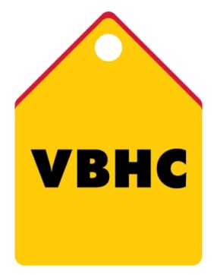
Document Control No : VBHC/HR/P/07
Revision No : Rev 1.1
Date of Revision : 01st April 2023

 | Name/Designation | Signature | Date
Written By | Shashidhar Rao
Reviewed By | Kumar GVS

HISTORY OF REVISIONS

Revision No. | Revision Date | Chapter/clause no.  & text affected | Reason for Revision

TABLE OF CONTENTS
SL No. | CONTENTS | PAGE NO.
1. | Purpose | 1
2. | Process Trigger | 1
3. | Scope and Application | 1
4. | Process Owner  5. | 1
5. | Successor and Predecessor | 1
6. | Responsibilities & Authorities | 1
7. | Definitions and Abbreviations | 2
8. | Process Flow Chart | 2
9. | Process Description | 2
10. | Efficiency measures and effectiveness measures | 4
11. | Risk associated with the process | 4
12. | Formats for maintaining records | 4
13. | Records | 4
14. | Annexure I | 5

EMPLOYEE ENGAGEMENT PROCESS

- PURPOSE
To establish processes that will measure and improve employee engagement that leads to higher employee performance/efficiency, higher productivity and higher employee retention.
- PROCESS TRIGGER
Employee Engagement is an ongoing process.
- SCOPE AND APPLICATION
This process is applicable to all employees at VBHC
- PROCESS OWNER
Head, HR
- PREDECESSOR AND SUCCESSOR PROCESSES
Predecessor Process: None
Successor Process: None

- RESPONSIBILITY AND AUTHORITY
Preparation of Questionnaire for survey : AVP, HR
Approval of Questionnaire for survey : Head, HR
Responsibility of conducting all Employees
Engagement Processes listed in step – 9.1 : AVP, HR

- DEFINITIONS & ABBREVIATIONS
- HR : Human Resource
- PROCESS FLOW CHART

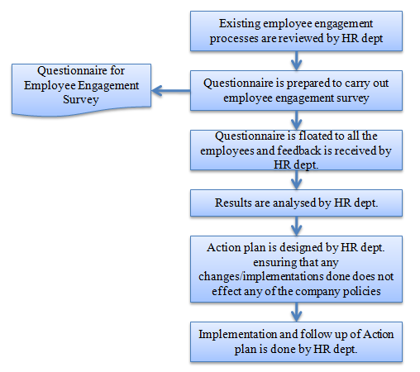

- PROCESS DESCRIPTION
  - Employee Engagement Processes:
As it is an established fact that there is a clear link between organizational performance and employee engagement, every organization seeking sustenance and growth in the ever changing world of work quickly respond to the needs of employees along with designing and implementing a customised process to increase the levels of employee engagement.
The following are the employee engagement processes followed at VBHC (differs from site to site and HO):
- Open Sessions and Management meets (refer document : VBHC/ P/ 001/07/ 779)
- Women's day celebration
- Celebration of festivals (Onam, Christmas and Dussehra)
- Celebration of Ethnic day/ Traditional day
- Employee Engagement Survey
- Fun
- Sports
- Pot Luck
  - Employee Engagement Survey:
    - Existing employee engagement processes are reviewed once in 2 years and survey areas of improvement are identified by AVP, HR.
    - Questionnaire is prepared by HR team and approved by HR, Head to carry out employee engagement survey
    - The Questionnaire format may be changed based on survey areas of improvement which are identified by AVP, HR in consultation with HR, Head and communicated to TOP management.
    - Questionnaire is floated to all the employees and feedback is received by HR dept.
    - Results are a combination of score and subjective output. Results are analyzed and presented to the top management by AVP, HR.
  - Action Plan:
    - Based on survey results areas of improvement are identified by AVP, HR
    - An action plan is prepared by AVP, HR and approved by HR, Head.
    - Approved plan is implemented by AVP, HR
    - Implementation and follow up of Action plan is done by Asst. Manager – HR yearly.

- EFFECIENCY MEASURES AND EFFECTIVENESS MEASURES
Efficiency Measures: % of employees covered / participating in the activities
Effectiveness Measures: Quantitative score from the employee engagement survey
- RISK ASSOCIATED WITH THE PROCESS

- FORMATS FOR MAINTAINING RECORDS GENERATED IN THE PROCESS
Employee Engagement Survey Questionnaire
- RECORDS
Employee Engagement Survey Record – Minimum Retention Period – 1 year.

ANNEXURE I
Name of Format | Code
Employee Engagement Survey Questionnaire | VBHC/HR/F/09

