PERKS AND OTHER FACILITIES

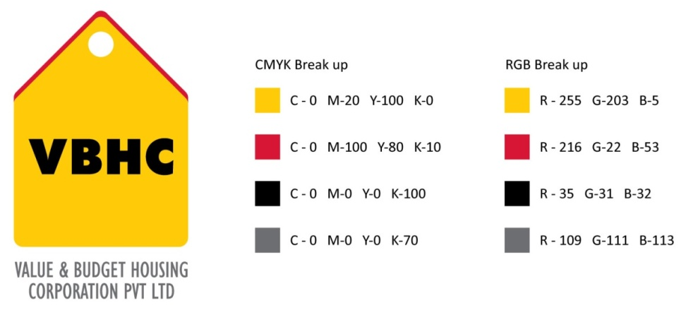
Document Control No : VBHC/HR/P/08
Revision No : Rev 1.1
Date of Revision : 01st April 2023

 | Name/Designation | Signature | Date
Written By | Shashidhar Rao
Reviewed By | Kumar GVS

HISTORY OF REVISIONS

Revision No. | Revision Date | Chapter/clause no.  & text affected | Reason for Revision

TABLE OF CONTENTS
SL No. | CONTENTS | PAGE NO.
1. | Purpose | 1
2. | Process Trigger | 1
3. | Scope and Application | 1
4. | Process Owner  5. | 1
5. | Successor and Predecessor | 1
6. | Responsibilities & Authorities | 1
7. | Definitions and Abbreviations | 1
8. | Process Flow chart & Description | 2
9. | Efficiency measures and effectiveness measures | 4
10. | Risk associated with the process | 4
11. | Formats for maintaining records | 4
12. | Records | 4
13. | Annexure I | 4

PERKS AND OTHER FACILITIES

- PURPOSE
To provide additional benefits apart from salaries to employees.
- PROCESS TRIGGER
This process triggers if any new employee joins or any existing employee requests for Salary Advance.
- SCOPE AND APPLICATION
This process is applicable to all the employee’s working at VBHC
- PROCESS OWNER
Head, HR
- PREDECESSOR AND SUCCESSOR PROCESSES
Predecessor Process: None
Successor Process: None
- RESPONSIBILITY AND AUTHORITY
Approval of SA upto Rs 50,000 : AVP, HR
Approval of SA above Rs 50,000 : Head, HR
Responsibility of providing GP, GMC & ESI to the employee : AVP, HR
Responsibility of handling Claims : AVP, HR
- DEFINITIONS & ABBREVIATIONS
- SA : Salary Advance
- HR : Human Resource
- GPA : General Personnel Accident Policy
- GMC : General Mediclaim Coverage
- ESI : Employee’s State Insurance
- PROCESS FLOW CHART
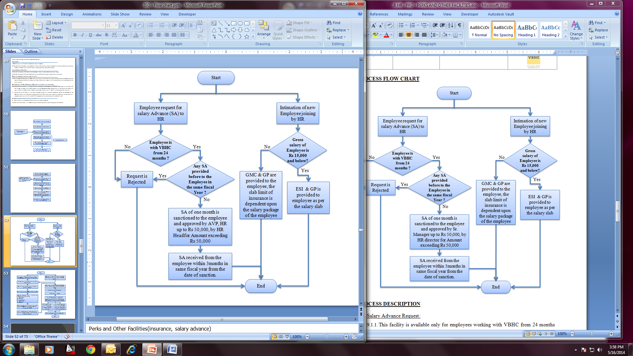
- PROCESS DESCRIPTION
  - Salary Advance Request:
    - This facility is available only for employees working with VBHC from 24 months and if no SA is provided before to the employee in the same fiscal year.
    - HR dept. receives employee request for salary Advance (SA) through email
    - SA of only one month gross salary is sanctioned to the employee and approved by AVP, HR up to Rs 50,000, by Head, HR for Amount exceeding Rs 50,000 in consultation with Top Management.
    - SA is recovered from the employee within 3months in the same fiscal year from the date of sanction.
  - Insurance Provision:
  - Intimation of new employee joining is given by HR Team to the Insurance Broker.
  - GMC & GPA are provided to the all employees.
  - Handling Claims:
    - HR team provides Claim Form to the employee who wants to claim.
    - HR collects following from the employee (all Originals):
- Discharge summary
- Medical bills
- Lab reports
    - HR receives the claim form from the employee and sends filled claim form attached with the documents collected from employee to the Insurance Brokers through courier. This should be done by HR within 21 days of discharge from the hospital
    - If any other documents are required, Brokers directly coordinates with the employee.
    - Claim process takes minimum 45 days
    - Prudent issues the cheque to HR dept, and AVP, HR hands it over to the employee.
- EFFECIENCY MEASURES AND EFFECTIVENESS MEASURES
Efficiency Measures: Average time taken to disburse SA
Effectiveness Measures: Employee Satisfaction about the transactions

- RISK ASSOCIATED WITH THE PROCESS

- FORMATS FOR MAINTAINING RECORDS GENERATED IN THE PROCESS
Claim Form
- RECORDS

ANNEXURE I
Name of Format | Code
Claim Form | VBHC/HR/F/10

