EMPLOYEE SEPARATION PROCESS

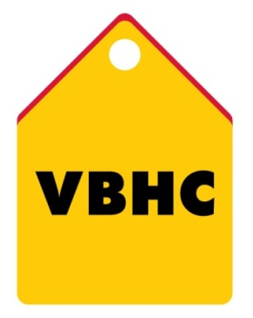
Document Control No : VBHC/HR/P/09
Revision No : Rev 1.1
Date of Revision : 01st April 2023

 | Name/Designation | Signature | Date
Written By | Shashidhar Rao
Reviewed By | Kumar GVS

HISTORY OF REVISIONS

Revision No. | Revision Date | Chapter/clause no.  & text affected | Reason for Revision

TABLE OF CONTENTS
SL No. | CONTENTS | PAGE NO.
1. | Purpose | 1
2. | Process Trigger | 1
3. | Scope and Application | 1
4. | Process Owner  5. | 1
5. | Successor and Predecessor | 1
6. | Responsibilities & Authorities | 1
7. | Definitions and Abbreviations | 2
8. | Process Flow Chart | 2
9. | Process Description | 3
10. | Efficiency measures and effectiveness measures | 4
11. | Risk associated with the process | 4
12. | Formats for maintaining records | 4
13. | Records | 4
14. | Annexure I | 5

EMPLOYEE SEPARATION PROCESS

- PURPOSE
This procedure covers professional conduct of a voluntary or involuntary termination of service of an employee to comply with statuary requirements in a manner to uphold the VBHC brand.
- PROCESS TRIGGER
This process triggers when any of the following occurs:
- On receiving resignation letter from any of the employee by HR
- On receiving information about any employee termination from Sr. HR Manager, who in turn receives it from HR Director
- SCOPE AND APPLICATION
This process applies to all the employees at VBHC
- PROCESS OWNER
Head, HR
- PREDECESSOR AND SUCCESSOR PROCESSES
Predecessor Process: None
Successor Process: None
- RESPONSIBILITY AND AUTHORITY
To conduct Exit Interview : Head, HR
Approval of Termination letter : AVP, HR

- DEFINITIONS & ABBREVIATIONS
- HOD : Head of Department.
- HR : Human Resource.
- IT : Information Technology.
- SF : Sales Force
- F & F : Full and Final Payment.

- PROCESS FLOW CHART
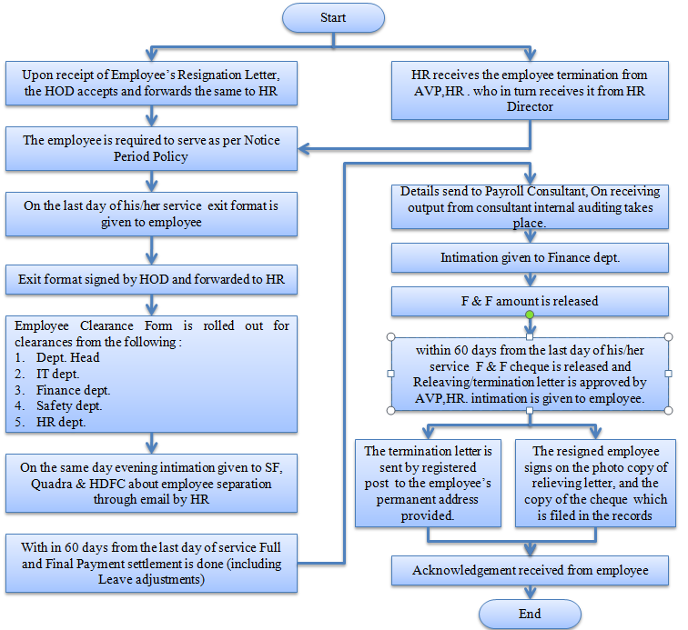

- PROCESS DESCRIPTION
  - Upon receipt of Employee’s Resignation Letter, the HOD accepts and forwards the same to HR team. The relieving date is communicated to employee through email in response to the resignation email by HR team.
  - HR receives the employee termination from AVP, HR.
  - On the last day of his/her service exit format is given to employee by HR Executive
  - Employee Clearance Form is rolled out for clearances from the following departments on the last working day of employee:
- Dept. Head
- IT dept.
- Finance dept.
- Admin dept.
- HR dept.
  - On the last working day of employee by evening intimation is given to SF, Quadra & HDFC about employee separation through email by HR team.
  - Exit form is given to employee by HR, Executive on the last working day of employee and Exit interview is conducted by AVP, HR
  - Within 60 days from the last working day Full and Final Payment settlement is done (including Leave adjustments, phone bill etc.,) by HR team.
  - The Details of the same are send to Payroll Consultant, on receiving output from consultant internal auditing takes place and intimation given to Finance dept. for Full and Final cheque.
  - F & F amount is released
  - Within 60 days (Because of phone bills mostly. It is generated on 24th of every month. 60 days is the maximum limit) from the last day of his/her service F & F cheque is released and Relieving/termination letter is approved by AVP, HR, intimation is given to employee. (The relieving letter is issued only when all the dues pending are cleared, else termination will not provide relieving letter)
  - The termination letter is sent in absconding cases by registered post to the employee’s permanent address provided. Receipt no. of the mail is kept as proof of intimation to the employee in case he/she does not send the signed copy.
  - The resigned employee sign on the photo copy of relieving letter, the copy of the cheque is filed in the records and acknowledgement is received from the employee.

- EFFECIENCY MEASURES AND EFFECTIVENESS MEASURES
Efficiency Measures: Average time taken to complete F & F (Maximum 60 days or minimum30-40 days)
Effectiveness Measures:
- RISK ASSOCIATED WITH THE PROCESS
Existing employees my damage VBHC brand name if they are dissatisfied with the separation process
- FORMATS FOR MAINTAINING RECORDS GENERATED IN THE PROCESS
Employee Clearance Form
Exit Form
- RECORDS

ANNEXURE I
Name of Format | Code
Employee Clearance Form | VBHC/HR/F/11
Exit Form | VBHC/HR/F/12

