
VBHC VALUE HOMES PVT LTD

HEALTH AND SAFETY MANAGEMENT

Document Control No : VBHC/EHS/01
Revision No : Rev 3.0
Date of Revision : 1st August 2023

Document Approval
 | Name | Designation | Date | Signature
Prepared By | Mr. Sameer V. Amburle | Manager - EHS | 1st August 2023
Reviewed & Approved By | Mr. GVS Kumar | Head - Projects & Operations | 1st August 2023

TABLE OF CONTENTS

SL No. | CONTENTS | REMARK
1. | Cover Page
2. | Introduction
3. | General
4. | Safety Health & Environment (SHE) Targets & Goals
5. | Project HSE Objective
6. | EHS Policy
7. | Process Trigger
8. | Scope and Application
9. | Process Owner
10. | Responsibilities & Authorities
11. | Project HSE Management
12. | Hazards Identification, Risk Assessment And Control
13. | Work Equipment
14. | First Aid
15. | Fire Prevention
16. | Incident Accident & Reporting Investigation
17. | Emergency Response Plan
18. | Definitions and Abbreviations
19. | Process Flow Chart
20.. | Process Description
21. | Records

Introduction:

INTRODUCTION

This document illustrates the principal requirement of VBHC on safety Environment & Health associated with Contractor.

GENERAL

VBHC’s Safety Management System Manual provides the framework for managing all aspects of the development. This safety Management manual summarizes:
  - Safety team, their roles, and responsibilities

  - Successful accident-prevention principles and techniques

  - Management of Hazards

  - Continuous improvement in SHE performance

SAFETY, HEALTH, AND ENVIRONMENT (SHE) TARGETS & GOALS

The SHE targets, goals & aim for the workers are to achieve:

  - Zero total recordable injuries.

  - Zero reportable environmental incidents

  - 100% incident recording and reporting

  - 100% adherence of usage of appropriate PPEs at work

- Project HSE Objective:
The objective of this HSE Plan is to provide requisite guidelines, based on
‘Actual site conditions’ and ‘Safety requirements’ of the company at VBHC Value Homes Pvt. Ltd for effective implementation of HSE policy, to ensure ‘Zero-Accident’ environment.
The goal for VBHC is “Zero Incidents” which is reflected in the project objectives which are as follows:
- No injury to personnel.
- No damage to the environment.
- No damage to equipment’s and materials.

Further VBHC will ensure a proactive approach to HSE by all personnel through the following performance targets:
- Active involvement in Safety Meetings, Safety Inspection and Toolbox
Talks.
- Encouraging safety awareness and always thinking of the risks associated with the work being performed.

- SAFETY POLICY:

VBHC VALUE HOMES PVT LTD

ENVIRONMENT, HEALTH & SAFETY POLICY

“VBHC strives to attain and maintain high standards of Environment, Health and Safety (EHS) policy throughout its workplace and strictly adhere to the safety policies adapted from time to time in this course of construction achieving ZERO incident at all levels and times.”
Head – Projects & Operations
For Vbhc Value Homes Pvt Ltd

29.02.2022
Date: -------------------------

- PROCESS TRIGGER
The process triggers when any one of the following occurs:
- EHS Supervisor receives intimation from Contractor/Engineer about joining of new Employee/Worker.
- If any safety issue observed at site by EHS Supervisor.

- SCOPE AND APPLICATION
This procedure applies to the entire site Employees/Workers at VBHC.
- PREDECESSOR AND SUCCESSOR PROCESSES
Predecessor Process: Award of contractor / Start of the project
Successor Process: Site Implementation

- RESPONSIBILITY AND AUTHORITY

Project In-charge / Project Manager

Project Manager / Site In-charge who directs and control the personnel at site is responsible for implementation of safety policy and the safety and health of personnel under their supervision, direction or control. This responsibility also includes the safe operations and safety of equipment / machinery at site.
They will:
- Enforce, lead, direct and follow up administration / execution of safety, health, and environment procedures.
- Set examples by wearing the personal protective equipment like helmets, shoes etc. and persuade, appeal and discipline personnel under their control to wear the same as a habit.
- Ensure regular inspections and surveys to ensure that facilities and equipment are operated and maintained to a high standard of safety so that risk of injury to personnel, breakdown and damage of property is minimized and high quality of output is achieved coupled with safety.
- Give weight age to safety performance while appraising performance of employees.
- Integrate safety and health in all decisions dealing with purchase of plant, machinery, material, and personal protective equipment.
- Plan and maintain desired standards of Housekeeping.
- Ensure efficient functioning of ‘Safety Officer’ and follow up decisions made to improve existing standards.
- Ensure implementation of recommendations of the statutory authorities and others

  - Project Engineer / Supervisor

Concerned Engineer / Supervisor on a particular work location will be responsible for Safety & Health of all employees under their direct & indirect control. His functions will mainly include: -
- To identify hazards and ensure control measures on the work spot on day-to-day basis.
- To remove any unsafe conditions that may have arisen during the previous shift or working activity.
- Close monitoring of activities of all workmen to weed out any unsafe practices adopted by them. He will also be responsible to ensure that all tools, equipment’s and other means of work are safe to operate.
- Usage of Safety helmets, Safety shoes and other items of personal protection by one and all, under his span of control.
- Investigate and report all incidents / accidents/ including near miss accidents on the prescribed Performa to the Site Safety Officer / In-charge immediately.
- Analyze cause of serious accidents, ensure implementation, and follow up of control measures.
- Take all necessary steps to prevent recurrence of any incident.
- Encourage participation of workmen in safety suggestion and training etc.
- Issue instruction to new employees on safety or approach the ‘Site Safety Officer’ to ensure the same.
  - Safety Officer / Site Safety In-charge

The Safety Officer will be responsible for the administration of the company’s Safety Program under directives of the Project Manager / Site In-charge and is
authorized to interact with corporate HSE Dept for any matters requiring his attention.
His functions will include the following:
- Assist and advise Project In charge, Site Engineers, Supervisors and Workmen in implementation of the requirements outlined in the ‘Safety Manual’ and periodically review the progress of implementation by visiting the sites on regular basis.
- Conduct Toolbox meetings and safety training for personnel at site and organize training for project personnel as per training needs.
- Provide up-to-date information of safety requirements commensurate with different types of work at various locations of work.
- Assist Site In-charge, Engineers in investigation of serious accidents in order to
- determine contributing causes with a view to prevent their recurrence.

- Giving First Aid in case of emergencies.
- Advice the purchase department at site in procurement and usage of personal protective equipment.
- Organize Induction training for new employees/Workers. .
- Compile safety records, statistics at site and submit monthly report to Corporate HSE Dept. Organize Safety promotional activities like display of safety posters, slogans and other educative materials, competitions & awards, as well as safety day celebrations etc.
- Interact and liaise with clients/outside agencies/companies to update information, documentation on Safety.

  - All Workmen

The workmen will: -
- Comply with necessary rules, regulations, do’s and don’ts and other instructions issued by line supervisors from time to time.
- Report all unsafe conditions, equipment’s prevalent in their respective work area to their immediate supervisor.
- Report all accidents, incidents and near misses immediately.
- Maintain a neat, clean, tidy, and orderly work area.
- Not remove or make ineffective any protection device or guard provided for their own protection or for the protection of their co-workers and environment.
- Not willfully endanger their own and their fellow workmen lives.
- Co-operate with the Site Safety Committee representatives.

- Project HSE Management
This is applicable to all employed in construction activities for ‘VBHC Group Projects and extends up to ‘Sub-contractor’ in the same sense. The company shall monitor the ‘Sub-contractor’ performance in managing safety aspects.
Project Manager/Project In-charge of site is responsible for ensuring coordination and implementation with other site ‘Sub-contractors’ for any matter pertaining to HSE.
Corporate HSE Dept will have a two -way communication on HSE related issues with ‘Site Safety In-charge’/ Project In charge.
Corporate Safety Coordinator will coordinate and review on implementation of
HSE project wise.

  - Overall HSE activity Control

Overall control of HSE activities is set by the requirements of VBHC Corporate Management system and shall be complied with, unless modified by project specific requirements.

The project HSE Plan is developed for project based on VBHC corporate management system and contractual requirements.
It is subject to approval by Project Director /Executive Director prior to submission to the clients /Project Management Consultant. Any change to or amendments are to be subject to the same approvals.

- HAZARD IDENTIFICATION, RISK ASSESSMENT AND CONTROL

  - HAZARD IDENTIFICATION

Identifying and managing hazards and adverse effect of activities is a vital part of HSE management. VBHC HSE management is designed to do this, and this process has been divided into four basic steps of identify, Assess, Control with the aim of reducing risk to a level that is “As Low as Reasonably Practicable (ALARP).
The main purpose of the hazard analysis and risk control process is to ensure that appropriate issues are addressed, and correct action taken by all parties involved in the projects.
  - RISK ASSESSMENT

The purpose of risk assessment process is to ensure that hazards identified in the workplace have associated risks assessed; thus, enabling the company to implement the necessary control measures in the systematic manner, to eliminate or reduce risk.
Risk Management involving hazard identification, risk assessment, identification of control measures will be performed by Project Management Team together with corporate HSE. Risk assessment activities will be performed in accordance with VBHC HSE Manual. (Refer Company HIRA Register for Reference).

- work equipment

5.1 PERSONAL PROTECTIVE EQUIPMENTS (PPE)

- All contractor workers shall be provided with adequate & proper safety helmets, good quality safety shoes.

- The persons engaged in noise area shall be provided with ear plugs / muffs.

- Approved safety belt (Full body harness) shall be provided for persons working at height.

- Fall Arrestors, Retractable Fall Arrestors, Safety Net, Guy Ropes, and modern Safety gadgets for working at height are to be used.

- Civil contract workers shall use the personal protective equipment’s as per the area they are working.

- Gumboots shall be provided wherever it is found necessary i.e., activities involving waterlogged areas.

- No workers including woman workers shall be allowed to take up the job without proper personal protective equipment. It is the responsibility of the concerned supervisor to ensure the personal protective equipment and adequate safety measures.

- Breathing apparatus sets.

- All personal protective equipment’s should be in good quality.

    - Personal Protective Equipment’s (PPE’s)

The VBHC shall provide required PPEs to workmen to protect against safety and health hazards. Primarily PPEs are required for the following protections.
- Head Protection (Safety helmets).
- Foot Protection (Safety footwear, Gumboot, etc.)
- Body Protection (High visibility clothing (waistcoat/jacket), Apron, etc.)
- Personal fall protection (Full body harness, Rope-grab fall arrester, etc.)
- Eye Protection (Goggles, Welders glasses, etc.)
- Hand Protection (Gloves, Finger coats, etc.).
- Respiratory Protection. (Nose mask).
- Hearing Protection (Ear plugs, Earmuffs, etc.)

Safety Helmet Colour Code | Person to use
White | Staffs
Grey | Visitors
Bl ue | Contractor Supervisor/Foreman
Red | Electricians
Green | Safety Dept
Yellow | All workmen

- FIRST AID

    - Definition First aid

First aid to the injured is the immediate help or first assistance given to a casualty to preserve life before medical help is obtained or rendered.

5.2.2 First things first: -

  - Do not panic, keep calm so that you can handle situation more effectively.

  - Remember the A’, B’, Cs of life support

“A” = AIRWAY OPEN: If not, ensure it is.
“B” = BREATHING: If not, resort to artificial respiration.
“C” = CIRCULATION: If not, resort to “Cardiopulmonary Resuscitation”-
C.P.R.

  - Check the bleeding and arrange to stop it.

  - Look for signs of shock and fractures.

  - Loosen any clothing without disturbing the affected part.

  - Never give any unconscious person anything by mouth.

  - Separate the cause and the victim if possible (e.g. switch off electric supplies; remove the gas cylinder before assisting the casualty).

  - Keep the victim warm and reassured.

  - Take care that first aided does not become a casualty himself.

  - Simultaneously arrange for medical help.

First Aid Boxes.

First Aid boxes in accordance with the standard requirements shall be established at each work area, under the supervision of a person qualified to give First Aid.
5.2.4 First Aid Training.
Trained First Aider can give first aid at site. Minimum one member of safety Team should have first aid certification. Selected candidate from projects may be given first Aid Training by a professional organization.

- FIRE PREVETATION

5.3.1 It is necessary to prevent fires. The following shall be ensured to prevent fires.

- Inflammable waste shall be stored separately and tidily.
- Burning of waste / rubbish shall be controlled.
- Inflammable material shall be stored away from hazardous processes.
E.g., welding, fabrication areas. All storage areas shall have warning signs.
- Smoking shall be prohibited within 6 meters of storage of diesel pump, gas cylinders or other inflammable materials. “No smoking” signs shall be prominently displayed, and good ventilation ensured. No naked light or defective worn-out electrical cables shall be operated or run through this area.
- Heating and cooking appliances shall be carefully installed.

5.3.2 While doing hot work like gas cutting and welding which requires special considerations, the following shall be observed:
- Removing of the combustible material beyond the arc of sparks and spatters.
- No tarpaulins shall be used as protection against sparks.
- The work site after the work is completed, shall be checked to ensure fire is not smoldering.

5.3.3 Adequate fire extinguishers shall be provided on selected locations with an emphasis that site personnel know:
- The correct type of extinguisher and their location.
- Limitation of use according to type of fire.

5.3.4 Depending on identified fire prevention program, firefighting system should be placed at designated place. Inspection and monitoring of Firefighting Equipment’s to be done regularly. Training and demonstration on firefighting should be conducted for project personnel regularly. The Site Safety personnel shall explain the various requirements during site training programs.

- INCIDENT/ ACCIDENT REPORTING & INVESTIGATION

Initial reporting of incidents may be generated using their normal reporting format and will be dependent on the source of the incident. However, all the initial incident report shall be sent to Project in charge and Corporate HSE Department.
(VBHC - HSE Manual will provide details reporting procedure). This procedure defines the system for reporting and investigation of accident and the corrective action to prevent its recurrence.
This procedure is intended to assist in the accomplishment of the following:
- Reporting and recording of near miss, property damage, injury, fire, explosion and toxic release if any.
- Communication channel for the dissemination of information to all concerned to prevent its recurrence and future course of action.

Accident: It means an unintended occurrence arising out of and in the course of employment of a person which results into injury with or without damage to equipment / materials.
Incident: It means unplanned and uncontrolled event, like fire, spill, leak property damage etc. which results in damage to plant or equipment or loss of material without causing any injury to person.
Types of Accident:
- First Aid Case
- Lost Time Injury
- Fatal

6.1 Reporting of Accident and Incident
All the incidents /accidents / near misses / fire irrespective of their nature and magnitude shall be reported verbally immediately by the injured or a person closely associated with the event or by the supervisor or by the construction engineer to his superior.

All the fatalities and lost time Injuries must be investigated and reported to Company and Corporate HSE Dept through Project In charge This is followed by in writing
- EMERGENCY RESPONSE PLAN

7.1.1 The purpose of this section is to provide emergency plan for orderly evacuation of worker & employee in the event of any emergency. Emergency plan shall be communicated to all the staff & employees of VBHC GROUP and all Contract Workers.

7.1.2 An Emergency Response Bridging Document will be compiled to describe how all aspects of emergency response will function including details of lines of communication and reporting requirements together with description of the interface of the emergency response organization with the organization and the authorities.

7.1.3 Where specific procedures may not have been established, judgment shall be used to determine the best course of action.
Follow the guidelines below for assistance: -
- All emergencies are to be handled by the highest-ranking person present and assisted by the emergency squad.
- The highest-ranking person shall assign job to responsible person for making emergency calls.
- The emergency phone numbers are to be displayed at the Main entrance gate, office areas and assembly points.
- The highest-ranking person present shall determine the need of an ambulance or other emergency equipment.
- If Medical person is present, he shall call for the Ambulance.
- Where a catastrophic event has occurred, anybody can call for an ambulance.
- In all instances, the ‘Top Management’ shall be notified immediately by phone.

- SAFE OPERATION PROCEDURES:

8.1 EXCAVATION
8.1.1 General
- Excavation is one of the important phases of the construction activity. Due to insufficient attention to the safety aspects, it has become the cause of many accidents. It is therefore necessary to plan and execute all excavations in safe manner.
- It is to be ensured that personnel with thorough knowledge and experience of excavation work supervise all excavations.
- The integrity of the excavation and support system shall be inspected prior to the commencement of any work on a daily basis.
- Where there is the possibility of any ingress of water, then pumping shall be established with pumps being readily available for use and additional ladders placed for use in the event of the emergency evacuation.
- No excavation shall commence till the disposal area has been earmarked and is ready to receive the excavated material.

8.1.2 General Precautions

The following precautions shall be observed:
- Prevent the sides and the ends from collapsing by battering them to safe angle or supporting them with timber, sheeting, or proprietary support systems.
- Entry into unsupported excavations shall be avoided.
- No work ahead of the support.
- Work in trenches can be dangerous. Supports shall be provided if the work involves bending or kneeling in the trench.

8.2 WORK AT HEIGHT
8.2.1 General:
Fall from height is the single largest cause of serious accidents in the construction industry and therefore appropriate measures have to be taken to ensure that whenever workers are working at a height from which they can fall, suitable safety precautions have been taken.
8.2.2 Safety Precautions for Work at Height:
  - Engineering Control: - Working platform shall be provided with Guardrails at 1.1m, mid rail at 0.55 m and toe board at 15 cm.

  - Use of PPE- All fall protection safety PPEs like Safety Helmet, Safety Harness required for working at height.

  - Continuous supervision: While working at height, continuous supervision shall be done by contractor / VBHC Staff.

  - Safety Net Installation: Safety nets shall be installed at minimum three levels.

8.2.3 First level of safety net shall be installed at 6m below the top working floor which will be a double layer safety net composed of 2.5mm braded twine with 25*25 mesh size and shade net.

8.2.4 Second level of safety net shall be installed ~ 12m below first level. This net shall be like net on first level.

8.2.5 Third level of safety net shall be installed at Podium level 1. This shall be a triple layer net; with first layer being a 5mm braided twine and mesh size of 70*70mm. Second layer shall be a double layer net of 2.5mm braided type with 25*25mm mesh size. Third layer shall be shade net. Special type of safety net holding brackets has been designed to provide an inclination of 30° angle.

Use of Scaffolds

8.3.1 Scaffolding must only be erected, altered or dismantled by competent Scaffolder’s.

    - All scaffolds must be inspected minimum once a week and whenever alterations are made.

    - Never use any incomplete scaffold.

    - All scaffolds must be constructed of sound materials free from defects.

    - The following measures shall also be taken.

- The scaffold shall be constructed for the correct use (Light or Heavy duty).
- Securely fixed to existing structures or adequately buttressed.
- Items such as barrels, boxes, loose tiles or other unsuitable material & must not be used as supports for working platforms.
- All working platforms shall have guardrails at one meter height and shall also
have an intermediate rail at half height and a toe board.
- All working platforms shall be kept free of unnecessary obstruction or rubbish.
- Secured ladder access shall be provided.

8.3.6 LADDERWAYS (Fixed rungs or loops to masts etc.)
- Look for damaged welds.
- Look for missing rungs.
- Look for damaged rungs.
- Report any problems to your supervisor. Get repairs made urgently.
- Wear a safety belt or harness when work has to be done from any ladder way.

8.4 WORK IN CONFINED SPACE

8.4.1 General
The term ‘confined space’ has two defining features, firstly, it is a place that is substantially (though not always entirely) enclosed and secondly, there will be reasonably foreseeable risk of serious injury from hazards.
Some confined spaces are easy to identify, for example, closed tanks and sewers. Others are less obvious but may be equally dangerous, for example closed and unventilated or inadequately ventilated rooms and silos, ducts, culverts, tunnels, boreholes, bored piles, manholes, shafts, excavation, sumps, inspection pits.

8.4.2 The Hazards
The most likely hazards are:
- Flammable substances and oxygen enrichment.
- Toxic gas, fume or vapor.
- Oxygen deficiency.
- The Ingress or presence of liquids.
- Presences of excessive heat.
- Excessive humidity.

8.4.3 Entry procedures
Only persons who have been thoroughly trained, experienced and are physically fit shall be allowed to work in confined spaces after ensuring the place is safe to work. Persons with any of the following medical conditions shall not be allowed to work in confined spaces.
- A history of fits, blackouts, or fainting attacks.
- A history of heart disease or disorder.
- High blood pressure.
- Asthma / bronchitis or shortness of breath on exertion.

  - Hot Work Safety (Welding, Gouging and Cutting)

    - Gas cylinders in use shall be kept upright on a custom-built stand or trolley fitted with a bracket to accommodate the hoses and equipment or otherwise secured.

    - Hose clamp or clip shall be used to connect hoses firmly in both sides of cylinders and torches.

    - All gas cylinders shall be fixed with pressure regulator and dial gauges.

    - Non-return valve and Flashback arrester shall be fixed at both end of
cylinder and torch.

    - Domestic LPG cylinders shall not be used for Gas welding and Cutting purpose.

    - Powder or Carbon dioxide (CO₂₎ type Fire Extinguisher not
less than 5 kg shall be fixed at or near to welding process zone in an easily
accessible location. Fire Extinguisher should confirm to IS 2190: 1992.

    - Use firewatchers if there is a possibility of ignition unobserved by the
operator. Oxygen cylinders and flammable gas cylinders shall be stored separately, at least 6.6 meters (20 feet) apart or separated by a fireproof, 1.5 meters (5 feet) high partition.

    - Flammable substances shall not be stored within 15 meters of cylinder storage areas.

    - Welding Machine used for electrical arc welding shall be fixed with Ammeter and Voltmeter and fixed with separate main power switch.

    - Welding grounds and returns should be securely attached to the work by cable lugs by clamps in the case of stranded conductors or by bolts for strip conductors.

    - The ground cable will not be attached to equipment or existing installations or apparatus.
    - Use a low voltage open circuit relay device if welding with alternating current in constricted at damp places.

    - Avoid being in contact with water or wet floors when welding. Use duckboards or rubber protection.

8.6 SITE ELECTRICITY

8.6.1 General
- All electrical installation work on site shall be carried out in accordance with the requirements laid down in the specification. All work shall be supervised and executed by qualified and suitably trained electricians.
- Temporary electrical site installation and distribution systems shall be in accordance with:
  - Indian Electricity Act and Rules.
  - The Power Companies Supply Rules.

8.6.2 Distribution of Supply
- The site mains voltage shall be as the electricity utility supplies. 415V 3- phase 4 wire system.

  - Single-phase voltage shall be as the electricity utility supplies, 220V supply.
  - The following voltage shall be adhered to for typical applications throughout the distribution system.
  - Fixed plant - 415 v - 3 phase.
  - Installation in site buildings 220 v - 1 phase.
  - Fixed flood lighting - 220v - 1phase.
  - Portable and handheld tools - 220v - 1 phase.
  - Site lighting (other than flood lighting) 220v- 1phase, and
  - Portable hand-lamps (general use)-230 v - 1phase.

- When the low voltage supply shall be energized via the employer’s transformer, any power utilized from that source shall be either 415v-3 phase or / 220 v – 1 phase as appropriate.

- Protection shall be provided for all main and sub-circuits against excess current, residual current and earth faults. The protective devices shall be capable of interrupting (without damage to any equipment or the mains or sub-circuits) any short circuit current that may occur.

- Earthing shall be provided for all electrical installations and equipment to prevent the possibility of dangerous voltage rises and to ensure that faults are rapidly cleared by installed circuit protection.

- Only plugs and fittings of weatherproof type shall be used.

- PROCESS FLOW CHART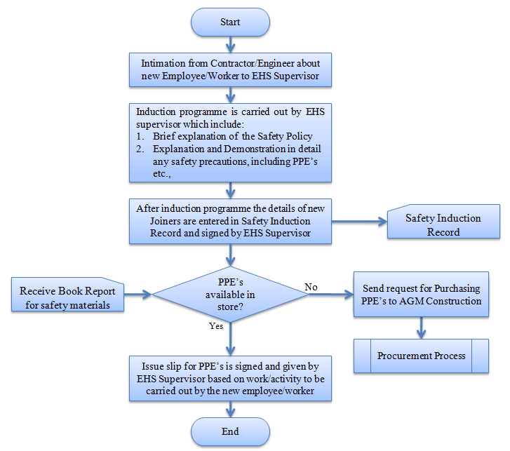

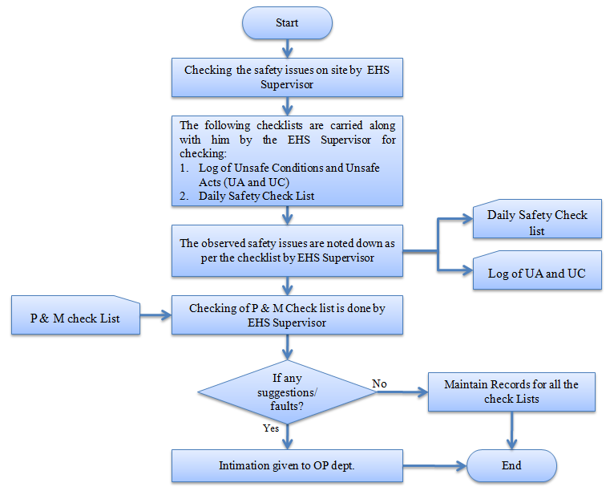

- PROCESS DESCRIPTION
  - Safety Induction Program:
    - EHS Supervisor receives intimation from Contractor/Engineer about joining of new Employee/Worker.
    - Induction program is carried out by EHS supervisor which include:
- Brief explanation of the Safety Policy
- Explanation and Demonstration in detail any safety precautions, including PPE’s etc.,
    - After completion of the induction program, the details of new Joiners are entered in Safety Induction Record and signed by EHS Supervisor.
    - If PPEs are available ready in the store, then issue slip for PPE’s is signed and given by EHS Supervisor based on work/activity to be carried out by the new employee/worker.
    - If PPEs are not available in the stock, then request for Purchase of PPEs to Project Head Construction.
    - The same is escalated for Procurement Process by Project Head Construction.
  - Daily inspection for safety issues:
    - EHS Supervisor checks the daily safety issues on site.
    - The following checklists are carried during daily inspection of safety issues at site by the EHS Supervisor:
- Log of Unsafe Conditions and Unsafe Acts (UA and UC)
- Daily Safety Check List
    - The observed safety issues are noted down as per the checklist by EHS Supervisor
    - P & M Check list done by Operations dept. is checked by EHS Supervisor
    - If any corrections observed by EHS Supervisor suggestions were written on the checklist and intimation is given to OP dept.
    - Records for all the checklists are maintained by EHS supervisor.
- RECORDS
Safety Induction Record – Minimum Retention Period – Till Project Completion
Daily Safety Check list – Minimum Retention Period – Till Project Completion
Log of UA and UC – Minimum Retention Period – Till Project Completion
Monthly Safety Report – Minimum Retention Period – Till Project Completion
Toolbox Talk Record – Minimum Retention Period – Till Project Completion
Accident/Incident/Near Miss Report – Minimum Retention Period – Till Project Completion
First Aid Record - Minimum Retention Period - Till Project Completion
Safety Calendar– Minimum Retention Period – Till Project Completion
Work Permit– (Height, Hot, Excavation work) – Minimum Retention Period – Till Project Completion.
Mock Drill Record – Minimum Retention Period – Till Project Completion.

Thank You.

PROJECT HSE PLAN

